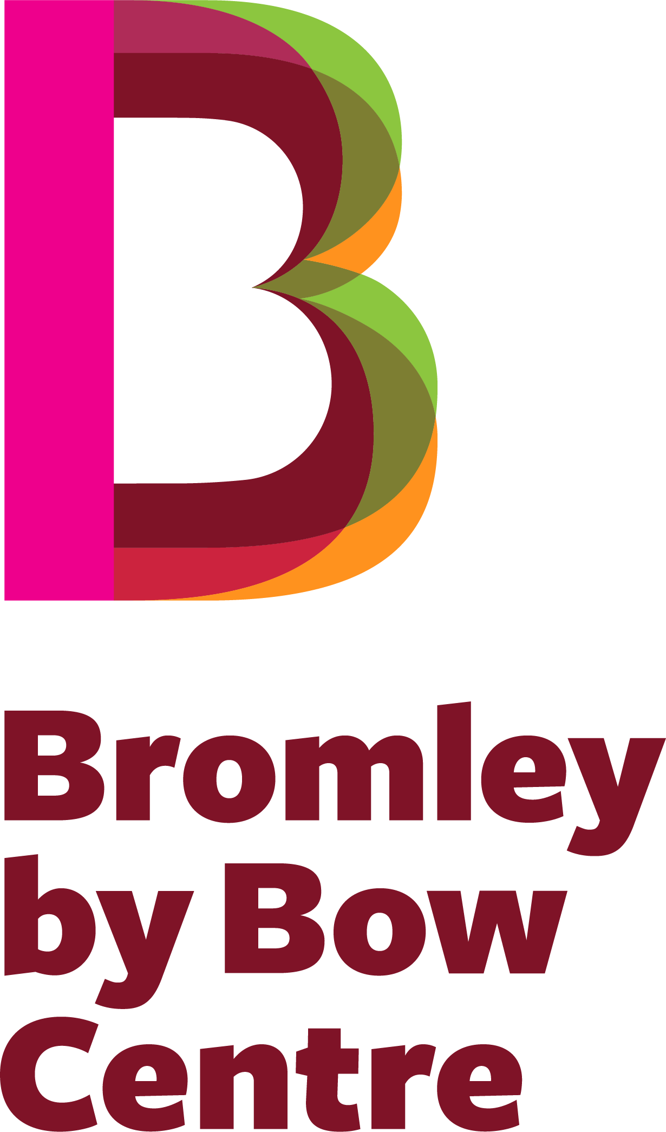
Bromley by Bow Centre
Job Application Form
Job you are applying for
Department or team
(if known)
First name(s)
Last / family name
Title
Address

Postcode
Telephone number
Email address we can use
Please tell us what attracts you to this job and how it matches your skills and experience
Tell us about your work history (including self-employment and volunteering)
Dates  (most recent first) |  | Employer’s name & address |  |  |  | Job role & key responsibilities |  |  |  |  |  |  |  | Reason for leaving
Your formal education and training (please start with your highest academic qualifications first)
Dates |  | School / College / University |  |  |  |  | Course(s) |  |  |  |  | Qualification / grade
Tell us about any other training you have had
Date |  | Details of the training |  |  |  |  |  |  |  |  |  | Qualification (if applicable)
First/native language
Other languages spoken |  |  |  |  |  |  |  |  |  | Level
 |  |  |  |  |  |  |  |  |  | Level
 |  |  |  |  |  |  |  |  |  | Level
Please name two people who can act as Referees
They should not be relatives. Employment is subject to satisfactory references. Your current employer will not be approached without your permission.
Name |  |  |  |  |  |  |  |  | Name
Job title |  |  |  |  |  |  |  |  | Job title
Organisation |  |  |  |  |  |  |  |  | Organisation
Relationship (to you) |  |  |  |  |  |  |  |  | Relationship (to you)
Email address |  |  |  |  |  |  |  |  | Email address
Telephone number |  |  |  |  |  |  |  |  | Telephone number
Do you consider yourself to have a disability? (according to the definition in the Equality Act) 2010?) |  |  |  |  |  |  |  |  |  |  |  |  | Yes ☐ |  | No ☐
If you have a disability please tell us about any
adjustments we need to make to assist you at interview

If you require any reasonable adjustments to the recruitment process, including the application process and interview,
please provide details on a separate sheet of paper
Are you free to remain and take up employment in the UK? |  |  |  |  |  |  |  |  |  |  |  |  | Yes ☐ |  | No ☐
Please note that you will be required to provide appropriate documentary evidence of this at interview.
For examples of acceptable documents please see www.ukba.homeoffice.gov.uk
Have you ever been convicted of a criminal offence which is not a spent conviction? (within the terms of the Rehabilitation of Offenders Act 1974) |  |  |  |  |  |  |  |  |  |  |  |  | Yes ☐ |  | No ☐
If yes, please give full details
The Bromley by Bow Centre undertakes not to discriminate unfairly against any applicant on the basis of a conviction or other information revealed
How did you hear about this job?
I confirm that to the best of my knowledge the above information is correct
Signature
Date
Please return this completed form to:
HR Team  Bromley by Bow Centre  St Leonard’s Street  London E3 3BT |  |  |  | Email: hr@bbbc.org.uk  Tel: 020 8709 9724
The Bromley by Bow Centre is a charity registered in England & Wales (no 1041653) and a Company Limited by Guarantee (no 2942840)

