BETTER CLUB 50+
BRITANNIA LEISURE CENTRE

A better range of healthy sport & physical activity sessions especially dedicated for those aged 50 years & over. Keep active and meet new friends.
Only £1.85 per day!

Please visit: http://www.better.org.uk/leisure/britannia-leisure-centre for an up-to-date timetable.

MONDAY | Activity | Location | Level
12.00noon – 4.00pm | SPA DAY (women only) | Health Suite | 50+ only
2.30pm–3.30pm | BADMINTON (coached) | Sports Hall | 50+ only
9.00am-5.00pm | GYM (GENERAL) | Gym | 50+ only
12.00noon-1.30pm & 3.30pm-5.00pm | SWIM (GENERAL) | Main Pool | 50+ only
TUESDAY | Activity | Location | Level
11.00am-12.00noon | GYM (coached) | Gym | 50+ only
1.30pm -2.30pm | CHAIR BASE EXERCISE | Sports Hall | 50+ only
9.00am-5.00pm | GYM (GENERAL) | Gym | 50+ only
12.00noon-1.30pm & 3.30pm-5.00pm | SWIM (GENERAL) | Main Pool | 50+ only
THURSDAY | Activity | Location | Level
12.00noon – 4.00pm | SAUNA | Health Suite | 50+ only
1.00pm – 2.00pm | AEROBICS | Studio | 50+ only
2.00pm – 3.00pm | WATER WORKOUT | Main Pool | 50+ only
9.00am-5.00pm | GYM (GENERAL) | Gym | 50+ only
3.00pm – 4.00pm | Swimming Lesson | Main Pool | 50+ only
9.00am—200pm  3.00pm-5.00pm | SWIM (GENERAL) | Main Pool | 50+ only

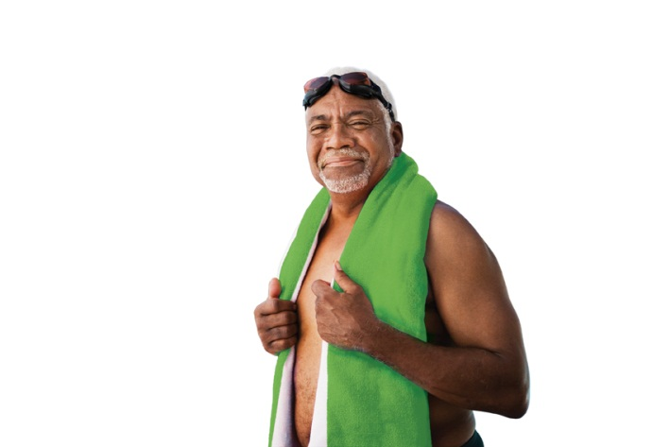

For more information visit: www.better.org.uk/britannia
or email any questions to: Britannia@gll.org

