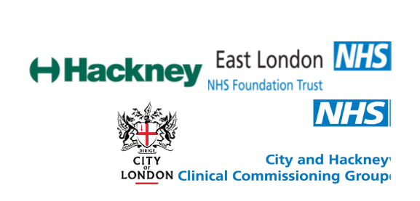

CITY AND HACKNEY MENTAL HEALTH STRATEGY 2019-23

Contents

Executive summary (on a page) ………………………………………………………………………………………………………. 2

1. Introduction 4

2. Vision, approach and priorities 6

3. Where are we now? The strategic environment 7

4. Where are we now? Understanding the needs of our communities 8

Delivering our Priorities 10

5. Priority 1: Prevention 10

6. Our priorities 2: Access 12

7. Our priorities 3: Neighbourhood 15

8. Our priorities 4: Personalisation and co-production 17

9. Our priorities 5: Recovery 19

10. Four building blocks 21

11 Development, oversight and accountability 22

|  |  |  |  |  |  |  |  |
| --- | --- | --- | --- | --- | --- | --- | --- |
| **Executive Summary**  **Our vision:** *‘Everyone will enjoy good mental health in the City and Hackney with access to the right care at the earliest opportunity when they need it, delivered as close to their local community as possible’.* | | | | | | | |
| **Our approach:** ‘*We are committed to working together to develop a whole system, all-age approach to mental health in City and Hackney, bringing together the NHS, local authorities, the voluntary and community sector, service users and other partners’.* | | | | | | | |
| **Our five strategic priorities:** | | | | | | | |
| **Prevention:** *We will prevent people from developing mental health problems in the first place, and provide help at the earliest opportunity when they do.* | **Access:** *We will improve access to mental health support and services, to reflect the diversity of our communities, the most vulnerable and those whose mental health problems are masked by other needs* | | **Neighbourhood** *We will aim to support people in the community wherever we can, working at ‘neighbourhood’ level with schools, GPs and voluntary and community services.* | | **Personalisation and co-production:** *We will continue to shift power and control to service users, giving them control of their own care and recovery, and working with them to identify their goals.* | | **Recovery:** *We will champion the social inclusion of people affected by serious mental health problems, focussing on their strengths and assets, housing, jobs and friendship networks.* |
| We will:   * Develop a ‘health in all policies’ approach * Implement a local transformation plan for CAMHS services * Work with employers on workplace mental health and wellbeing * Help people at the earliest opportunity * Prevent suicide | We will   * Expand open access to support * Improve access for people with complex needs like addictions and homelessness and physical health problems   Work with community organisations to reach under-represented groups and protected characteristicsand ensure earlier access to mental health pathways | | We will   * Develop the role of GP and primary care services * Develop multi-disciplinary teams around the person in neighbourhoods * Develop Community Dementia support in neighbourhoods | | We will:   * Expand the use of personal budgets * Develop service user led goals and care plans * Develop personalised online support * Use an Open Dialogue approach, involving service users’ families and networks in their care and recovery | | We will   * Develop the role of the Recovery College * Improve housing support and accommodation pathways * Support service users into training and work * Help people to build and maintain social networks |
| **Our building blocks:** | | | | | | | |
| **People**: *Develop our workforce capacity and skills and support carers, peer mentors and volunteers* | | **Engagement:** *Listen and learn by working with experts by experience, practitioners and partners* | | **Data and digital:** *Share data, building a shared evidence base and**develop digital options* | | **Evidence-based policy**: *Be guided by research and best practice, and monitor the impact of what we do* | |

# Introduction

* 1. This strategy sets out our priorities for mental health support and services across City and Hackney for 2019-2023. It has been developed and will be implemented as part of our Integrated Care Programme. It provides a framework to shape, inform and support improvements in mental health care in City and Hackney. It sets out a vision, priorities and direction of travel, and builds in the flexibility to develop them collaboratively going forward.
  2. It should be read alongside other key strategies. These include the *Joint Health and Wellbeing Strategies* and *Suicide Prevention Strategies* for both the City of London and Hackney and our *Local Transformation Plan* for Child and Adolescent Mental Health Services and the ELHCP Operating Plan.

### What is covered by this strategy?

* 1. The strategy assesses the needs of our population, maps the challenges, identifies the opportunities, and explains how we will work collaboratively as partners and with service users to deliver our priorities, as well as how we will monitor our progress.
  2. It considers how we will support the mental health and wellbeing of:
* Our residents
* The most vulnerable – e.g. the homeless and rough sleepers
* All sections of our diverse populations
* People who work in the City of London and Hackney.

It is also intended as a contribution to the development of national and pan-London mental health policy.

* 1. It considers mental health and wellbeing as part of the new integrated care system for City and Hackney, which is organised around four workstreams: ‘*prevention*’, ‘*planned care*’, ‘*unplanned care*’ and ‘*children, young people and maternity’*. The strategy sets out the approach to mental health across this system and seeks to ensure ‘parity of esteem’ with physical health in all that we do.
  2. It also explains how we will develop and apply the ‘neighbourhood model’ to mental health in City and Hackney, supporting people in their homes and communities wherever possible and mobilising community assets, whether that’s carers and friendship networks, the local GPs surgery or voluntary and community sector services.

### What is not covered in this strategy?

* 1. We are committed to developing an all-age approach to mental health and wellbeing in City and Hackney, and are working through the Integrated Care Programme to improve transitions from adolescent to adult services, particularly for our most vulnerable young adults.
  2. Our plans are set out in detail in the City and Hackney local transformation plan (LTP) for Children and Adolescent Mental Health Services (CAMHS). The Children, Young People and Maternity Workstream within the City and Hackney integrated care programme is overseeing the development and implementation of the LTP, as well as looking at other key areas of mental health provision, including peri-natal care and support. A brief summary of our approach to children and young people is provided as appendix 2 of this document.

### How was the strategy developed?

* 1. We have developed this strategy collaboratively, bringing together the City of London Corporation and LB Hackney, and NHS, local government, voluntary and community sector and other partners, working co-productively with mental health service users.
  2. It has been informed by an *Equality Impact Assessment* (EQIA), which will shape our approach to addressing the diversity of our communities going forward.
  3. It has been overseen by a Mental Health Co-ordination Committee (MHCC) of senior officers, providers and service users, supported by a Joint Mental Health Action Team, as part of the City and Hackney Integrated Care Programme. The MHCC will be accountable for the delivery of the strategy, monitoring progress against an Action Plan. Further political oversight and accountability will be provided by the City of London and Hackney Health and Wellbeing Boards. The MHCC will co-ordinate an annual review of progress and developments, to ensure we are responding to new learning, challenges and opportunities.
  4. It is our expectation that this strategy and the accompanying Action Plan will be naturalised within the planning and strategic processes of partner organisations as appropriate, to inform and drive delivery of objectives for which they have a lead responsibility.

# Vision, approach and priorities

* 1. Our local vision is that *‘Everyone will enjoy good mental health in the City and Hackney with access to the right care at the earliest opportunity when they need it, delivered as close to their local community as possible.’*
  2. Our approach will be to work together *‘to develop a whole system approach to mental health in City and Hackney, bringing together the NHS, local authorities, the voluntary and community sector, service users and other partners’*.
  3. Our focus will be on five strategic priorities:
* Prevention: *We will prevent people from developing mental health problems in the first place and provide help at the earliest opportunity when they do.*
* Access: *We will improve access to mental health support and services, reaching out to reflect the diversity of our communities, the most vulnerable and those whose mental health needs are masked by other needs or complexity.*
* Neighbourhood: *We will aim to support people in the community wherever we can, working at ‘neighbourhood’ level, with schools, GPs and voluntary and community services.*
* Personalisation and co-production: *We will continue to shift power and control to service users, giving them control of their own care and recovery, and working with them to identify their goals.*
* Recovery: *We will champion the social inclusion of people affected by serious mental health problems, focussing on their strengths and assets, housing, jobs and friendship networks.* 
  1. We will also focus on four building blocks, which will underpin our strategic priorities:
* People: *We will develop our workforce capacity and skills, recognise and support the role of carers and work in partnership with peer mentors and volunteers.*
* Engagement: *We will listen and learn by working with experts by experience, practitioners and partners*
* Data and digital: *We will improve arrangements for sharing and learning from our data and be innovative in developing the use of digital and technological resources.*
* Evidence-based policy: *We will be guided by research and best practice, and monitor the impact of what we do*
  1. We do not underestimate the challenges that we will face in the next four years, and the need to be *both* realistic *and* innovative. They include rising demand for mental health care at a time of increasing pressures on NHS and local government budgets. By working together, intervening earlier, empowering ‘experts by experience’, removing barriers to support and moving to neighbourhood models of care, we believe that we have an opportunity toimprove outcomes in a way that will also help us to manage the pressures on budgets, resources and services.

# Where are we now? The strategic environment

### **National policy**

* 1. Our approach in City and Hackney is shaped by NHS England’s *Five Year Forward View for Mental Health* (2016), which champions the principle of ‘parity of esteem’ for mental and physical health and identifies three Priorities for Action:
* *A seven-day NHS – right care, right time, right quality –*e.g., community-based crisis care
* *An integrated mental and physical health approach –* e.g., better physical health for people with severe mental health problems and better mental health for people who are physically unwell
* *Promoting good mental health and preventing poor mental health -* e.g., mentally healthy communities and improving employment rates.
  1. This strategy also addresses priorities set out in the *NHS Long Term Plan* (2019):
* *The neighbourhood model* with care delivered at neighbourhood level by multi-disciplinary teams of GPs, other primary care services, pharmacies and through the mobilisation of community services and assets
* *Personalised care,* including the use of online therapies and digital support and the roll out of Personal Health Budgets.
* *Severe Mental Illness* (SMI), with a focus on integrating primary and community mental health services to improve access to psychological therapies, medicines management, physical health care, trauma informed care, employment support, access to drug and alcohol treatment and support for self-harm*.*
* *Reduced A&E use and admission by people with SMI* with alternative support for those in crisis including sanctuaries and safe havens, crisis cafes, crisis houses, acute day services, host families and Clinical Decision Units.

* *Children and Young People* with a focus on the Green Paper *Transforming Children and Young People’s Mental Health* (2017), with an enhanced role for schools and a comprehensive offer for 0-25-year olds to support transition to adulthood.
  1. We will also build on local arrangements to support partnership responses to people in mental health crisis through the *Mental Health Crisis Care Concordat* (2014). We will adopt Public Health England’s *Prevention Concordat for Better Mental Health* in City and Hackney to support our focus on prevention and early intervention. Our politicians will provide leadership with designated Mental Health Champions at the City Corporation and Hackney, engaging with the Local Authority Mental Health Challenge.

# Where are we now? Understanding the needs of our communities

* 1. City and Hackney provides many excellent mental health, public health and social care services that are highly rated and, in some instances, have received national recognition.
  2. Our services face challenges, including:
* A relatively high number of people with severe and enduring mental health problems many of whom are in primary care settings and require ongoing support.
* A relatively high number of people with complex problems who are not accessing the right services either because their mental health problems are undiagnosed or because the different kinds of care they need are not well integrated. Many are high frequency users of A&E and primary care. Mental health issues may be masked by physical complaints, addiction, homelessness and chaotic lifestyles.
* In our richly diverse area some communities are less able to access care and support than others.

## **Mental health in City and Hackney: Key Numbers**

Fifth highest rate of psychotic and bipolar disorders in England, with 4,500 on the Serious Mental Illness (SMI) register.

Around 2,200 engaging with specialist mental health services in City and Hackney in the previous 12 months.

Three quarters of people with SMI managing their condition in the community supported by GP and primary care services, often with voluntary and community sector involvement.

Smoking rates among people with SMIs are 36% higher than the general population, and obesity rates 50% higher.

Life expectancy is between 8 and 18 years lower than for the general population.

An estimated 11,000 people in City and Hackney with a personality disorder

6,490 people in City and Hackney with severe and enduring mental health problems entered secondary care services in 2017-18, with 1,089 admitted as in-patients.

33,000 people in City and Hackney are experiencing depression and/or anxiety disorders at any one time

14,000 people are receiving repeat prescriptions of anti-depressants and around 1 in 5 accessing ‘talking therapies’ through the IAPT programme

The number of residents with dementia is expected to increase by one third by 2025, from 1,290 to 1,890

**See appendix 1 for a more detailed needs analysis for City and Hackney**

*INTERVENING EARLIER*

*SUPPORT AND CARE AS CLOSE TO THE COMMUNITY AS POSSIBLE*

*=*

*WHAT INDIVIDUALS WANT*

*REDUCES PRESSURES AND COSTS*

# **Implementing our approach to meet the needs of our population**

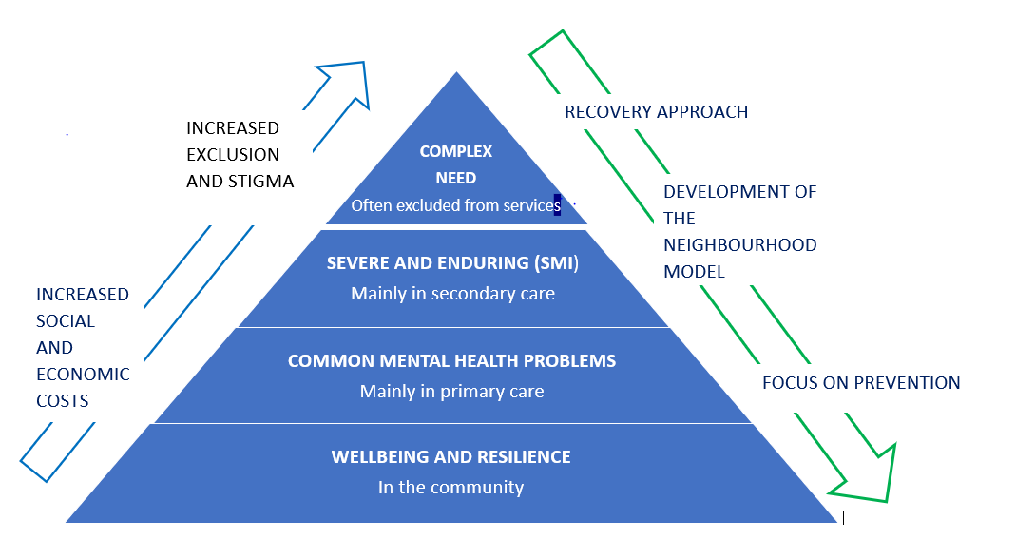

# Delivering our Priorities

# Priority 1: Prevention

*We will prevent people from developing mental health problems in the first place, and provide help at the earliest opportunity when they do*

### Why it matters

* 1. By preventing mental health problems from developing in the first place and from getting worse when they do, we will improve outcomes for individuals while reducing the pressures on specialist mental health services, as well as the wider economic and social impact of mental illness (e.g. for costs of acute and crisis care).
  2. We also have a responsibility for suicide prevention and recognise the importance of this priority given the devastating and wide-ranging impact on people and services.

### What we will do

* 1. Mental resilience, well-being and the prevention of mental illness is not just – or even primarily – an issue for NHS services. Our prevention agenda recognises the vital contribution of public health, schools, neighbourhoods and communities, the voluntary sector, businesses and employers, criminal justice agencies, the built and natural environments and services like planning, transport, leisure and culture.

|  |  |  |
| --- | --- | --- |
| KEY ACTIVITIES | | WE WILL …. |
| Mental health in all policies | | * Develop our built and green environment to promote mental health * Work across service departments to promote their role in mental health and to develop this (e.g., planning, transport, leisure and culture) * Adopt and apply the national Mental Health Prevention Concordat * Develop a dementia friendly community across City and Hackney |
| Early years, families and young people | | * Develop perinatal support * Build on the ‘Think Family’ approach for families known to social services * Develop designated senior mental health teams in schools and Mental Health Support Teams for early intervention and ongoing help at school * Develop our offer to children with Special Educational Needs and Disabilities * Implement the third phase of our Local Transformation Plan for Children and Young People’s Mental Health Services (CAMHS) |
| Workplace | | * Work with businesses and employers on workplace mental health * Support NHS workforce to access mental health wellbeing support * Support national campaigns like Release the Pressure |
| Mental health crisis and suicide prevention | | * Develop and implement the City and Hackney suicide prevention strategies * Samaritans-led Suicide Prevention Training, working with employers * Strengthen our crisis pathway with more accessible services that reach beyond statutory mental health services |
| Awareness and Information | | * Improving online information and use of digital channels and social media * Develop communications campaigns to support mental wellbeing |
| Get support to people quicker | * Develop open access and low threshold services (see priority 2 – Access) * Ensuring everyone in the City and Hackney with dementia can be diagnosed early with access to the right level of care at the right time | | |

## 

## **CASE STUDIES - SOME EXAMPLES of our work on PREVENTION**

***Preventing suicide …***

. The City of London Street Triage team works with police and aims to reduce suicide and unnecessary admissions. Other initiatives include the Crisis Café, rolling out Samaritan-led suicide prevention training and reducing the environmental risks (e.g. by signposting people to specialist help services on bridges and railway platforms). When suicides do occur, the circumstances and lessons are subject to review by Safeguarding Board, so lessons can be learned.

***Tackling social isolation and loneliness …***

The City and Hackney Safeguarding Adults Board is helping to lead and co-ordinate activity to address loneliness and social isolation among our residents. The Connect Hackney initiative has focused on social connectivity for older adults in the Borough. The City Corporations Social Wellbeing Strategy has driven a range of initiatives, including a Community Builders programme using resident volunteers on City Estates to connect people to each other and to services on the City.

***Five ways to thrive – simple mental wellbeing tips for everyone***

Across City and Hackney we are embedding our local ‘Five Ways to Thrive’ initiative into our communications resources, for a variety of audiences, including our residents, businesses and workers. This is based on the Five Ways to Mental Wellbeing Model that was developed by the New Economics Foundation. The five ways to thrive are to ‘connect’, ‘be active’, ‘take notice’, ‘keep learning’ and ‘give’.

***Supporting mental health in the workplace***

The City Corporation’s Business Health network is a community and online resource for business leaders committed to improving the health and safety of their workforce. A recent survey of City employers found that mental health was their number one priority, and this is being reflected in the planning and development of network resources, events and activities from 2019.

***Coping with life events***

LB Hackney is publishing a series of ‘Life Events’ support packs that provide ideas, advice, contact numbers and links to videos and online resources to help people to stay mentally resilient when they face big changes in their lives.

# Our priorities 2: Access

*We will improve access to mental health support and services, reaching out to reflect the diversity of our communities, and to the most vulnerable.*

### Why it matters

* 1. It matters because needs can remain undiagnosed and untreated where people are unable to access care and support, often with serious negative impact on people’s lives (e.g., alcohol and drug problems, loss of employment, debt, housing problems and homelessness), families and communities (e.g. family breakdown, crime or anti-social behaviour) and other services (e.g. A&E departments).

## Physical and Mental Illness: For Example

* 1. In City and Hackney we have high numbers of A&E, ambulance and 111 frequent attenders, placing significant additional pressures on NHS services. Evidence suggests that undiagnosed mental health problems are often a factor in complaints about physical illnesses. Untreated mental health problems are also a barrier to recovery from addictions and to pathways out of homelessness. People with complex needs can find themselves excluded from and passed between services.

Diabetes

Coronary Heart Disease

Serious Mental Illness



* 1. It also matters because some groups in our diverse communities are under-represented in our services, including young black boys and men, LGBTQ people and older adults. Furthermore, whilst some BME groups such as young black men are under-represented in terms of engagement in earlier stages of the pathway e.g. psychological therapies access, they are over represented at the more acute end in terms of inpatient admissions and the use of the Mental Health Act.

### Key figures

Only 15% of the street homeless population across City and Hackney have no identified alcohol, drug or mental health need. In City and Hackney, 386 people who started drug and/or alcohol treatment in 2017-18 had a mental health need (over 40%) – over a third of this group were receiving no treatment.

40% of ELFT inpatients detained under the Mental Health Act were from an african/afro-caribbean heritage background.

Nearly 275 people in City and Hackney have attended hospital and A&E services 10 times or more in a year without a clear physical cause, over 3,000 attendances.

In Hackney in 2017-18, 58 of 118 rough sleepers (49%) had mental health needs

In the City of London, 151 of 265 rough sleepers (57%) had mental health needs.

15,169 patients in City and Hackney who have diabetes, of which 2,471 (18%) have uncontrolled diabetes

## What we will do

* 1. We will develop ‘open access’ mental health support and focus on addressing the (often undiagnosed) mental health needs of four key groups who may be excluded from services: frequent A&E, ambulance and 111 services; the homeless and rough sleepers; people with and in recovery from addictions; and equalities groups.

|  |  |
| --- | --- |
| KEY ACTIVITIES | WE WILL …. |
| Open access | * Introduce whole school approaches to mental health and wellbeing * Develop our no wrong door approach to CAMHS services * Develop open access services like the Recovery College * Expand immediately accessible crisis services in City and Hackney * Improve access for people in crisis through mental health street triage |
| Physical health and mental health | * Develop assessment, referral and integrated care pathways to diagnose and address the mental health needs of people presenting with physical illness * Target action to reduce numbers of frequent users of A&E, ambulance and mental health services by addressing undiagnosed mental health need * Build on our programme of physical health reviews for people with SMIs, by increasing their frequency and strengthening the support offer for those at risk of physical illness * Pilot sport and healthy eating programmes for people with SMIs |
| Dual diagnosis and complex need | * Invest in Multiple Needs Service for those with multiple and complex needs * Equip and develop our workforces to work collaboratively and flexibly across service and professional boundaries * Support our substance misuse services to develop integrated approaches with mental health services to support people with ‘dual diagnosis’ * Continue to provide tailored support for people who are homeless or sleeping rough taking account of chaotic lifestyles and complex need * Develop the ‘housing first’ approach to rough sleeping * Work with businesses to improve understanding and address the links between alcohol and drug misuse and mental health in the workplace |
| Addressing diversity | * Develop effective pathways and provision for key equalities groups, with a focus on young black boys and men, the LGBTQ community and older adults through links with communities, community champions and community organisations * Monitor equalities in assessing delivery of our strategic priorities and actions and performance of our services and those we commission * Ensure under-represented groups are better represented in the workforce * Ensure that services meet the needs of under-represented groups and do not prevent barriers to access |

## **CASE STUDIES – SOME EXAMPLES of our approach to ACCESS**

***New Mental Health Centre ….***

The City Corporation is commissioning a provider for a new Mental Health Centre, offering rent-free premises in the Square Mile for over three years, to provide low cost sessions for low income workers and residents, and long-term therapies that are not readily available through the NHS. It is intended that providers will charge those most able to pay and offer subsidised sessions to those on lower wages or not able to pay for other reasons.

***Releasing the pressure …***

The Dragon Café welcomes anyone who is feeling the pressures of work or life in and around the City of London. It is hosted in Shoe Lane Library in the City, and offers a programme of activities designed to release pressure, reduce stress and build resilience. It is free, open to all and with no requirement to register or book in advance.

***Physical and mental health***

City and Hackney is piloting a new service for people who make intensive use of A&E or London ambulance services, where physical illness may reflect underlying psychological issues. The service will be accessible to anyone who is a frequent user of these services, regardless of whether they have a formal mental health diagnosis and offer psychological, emotional and practical support.

***Helping people in crisis get timely help ..***

After a successful pilot the City Corporation, City of London Police and City and Hackney CCG are funding a Mental Health Triage System to operate in the City for seven days a week. Mental health professionals accompany police on patrol and can intervene where people are experiencing a crisis that might otherwise lead to them being ‘sectioned’ under the Mental Health Act. By getting the right support in the community, this improves outcomes for individuals and reduces the pressures on acute and crisis services.

***Supporting the most vulnerable …***

A dual diagnosis treatment pilot has been commissioned by LB Hackney and the Greenhouse Clinic, targeting people with mental health and substance misuse problems – particularly, but not only, homeless – who are likely to be excluded from mental health services due to their drug or alcohol misuse. The pilot will inform a new model to inform the re-commissioning of integrated adult substance misuse services. This will include a focus on those who are finding it most difficult to access help, including those with a dual diagnosis and the homeless.

# Our priorities 3: Neighbourhood

### Why it matters

* 1. The City and Hackney Integrated Care Programme is implementing a neighbourhood model of health and social care, and this is also at the heart of the *NHS Long Term Plan*. This model will align local services at a neighbourhood level with responsibility for population based health covering 30,000-50,000 people. NHS England is making £4.5 billion available nationally to support the development of this model locally over the next five years.

*We will aim to support people in the community wherever we can, working at neighbourhood level with schools, GPs and voluntary and community services*

* 1. Shifting the balance of care into neighbourhoods offers significant opportunities for improved integration between primary and secondary care, between social care and health services and between mental health and physical health services.
  2. City and Hackney has comparatively advanced primary care mental health services. They include an Enhanced Primary Care (EPC) and a Primary Care Liaison (PCL) service, along with a Primary Care Psychotherapy Consultation Service. We also have a high performing IAPT service, delivering ‘talking treatments’ with a focus on common mental health problems, particularly anxiety and depression. However, there are still many gaps particularly for people with complex or severe and enduring mental health problems, who are outside a secondary care setting.
  3. Working with the voluntary and community sector, and further integrating local authority and NHS services, we also have plans to improve the level of social support available in GPs surgeries and other primary care settings – this could include, for example, help with debt and financial management, housing and employment support.
  4. There is a concern about the over-representation of black men within crisis and forensic services. Developing the neighbourhood model provides an opportunity to start to address this, by working closely with local communities and providing an integrated wrap around service that should be well adapted to address the social determinants that impact the emotional wellbeing of this group.

## What we will do

* 1. Building on the emerging neighbourhood model we will shift the balance of care provision from secondary to primary care by strengthening community-based provision in primary care practices, schools and other community organisations, developing care navigation at local level and creating inter-organisational teams and approaches.

|  |  |
| --- | --- |
| KEY ACTIVITIES | WE WILL …. |
| Neighbourhood teams | * Develop ‘teams around the person’ with virtual teams from different organisations formed around the patient - teams will have a designated lead professional but will put the patient at the centre of their care plan |
| Focal points for care | * Develop the roles of navigators, care co-ordinators, social prescribers and coaches in an integrated way to create a ’seamless service’ for the service user * Ensure everyone diagnosed with dementia has a named navigator from diagnosis to end of life where VSO are a key part of the community wraparound support * Develop transition services and pathways in the community, especially for young people falling out of conventional mental health services |
| Culture, skills and confidence | * Implement recovery and co-production models for neighbourhood mental health provision * Continue to improve the care provided in primary care andthrough community organisations and networks through mental health training and awareness initiatives |
| Dementia | * Create a neighbourhood-based dementia service with continuity of care from diagnosis to death * Support and work with community organisations to support people living with dementia, their carers and families |

## **CASE STUDIES – SOME EXAMPLES of our approach to NEIGHBOURHOODS**

***… And Stepping Up***

For Assessment and Brief Treatment we want to expand and provide more ongoing support for with severe and enduring mental health problems including people with psychotic bipolar, personality disorders and trauma.

We want to explore and pilot models for a step-up service to provide timely interventions in the community for people with severe and enduring mental health issues, who may otherwise need secondary care services. VSO’s in City and Hackney will be a key part of community wraparound support people will receive.

***Stepping down …***

The City and Hackney Enhanced Primary Care (EPC) Service supports people with severe and enduring mental health problems to ‘step’ down from specialist, secondary NHS services and be supported in the community, with regular GP reviews and input from a mental health liaison worker. Since widening access to more people with more complex problems - like personality disorders – it is now working with 500 to 600 people a year. Recovery Plans, produced with service users to reflect their goals, will be developed so they can be carried over as people step down into primary care services. We want to expand to cover discharge packages for a great number of people - c6,000 per annum.

***Community Dementia Service***

A neighbourhood based dementia service will offer continuity of care for patients diagnosed with dementia, from initial assessment and diagnosis through to end of life provision. People with Dementia will benefit from community based services which offers timely diagnosis where residents and their carers receive the right level of care and support at the right time.

# Our priorities 4: Personalisation and co-production

*We will continue to shift power and control to service users, giving them control of their own care and recovery, and working with them to identify their goals*

### Why it matters

* 1. Involving service users in the development of plans and services ensures that we are addressing need and working with people’s assets with a focus on their goals and aspirations; addressing the priorities and improving the quality of support provided to the people who use our services. Listening to ‘experts by experience’ is also critical if we are to design and deliver services that work for people and as part of an integrated care programme.

*‘Shaping the services you use is empowering. It’s refreshing to know they want to hear from people using services.’*

It is:

*‘A stronger voice in the community with the support of peers’*

*‘A constructive way of getting things done and being listened to’*

*‘Being part of something’*

**Service user responses to a review of the recovery planning in City and Hackney**

* 1. Co-production is also critical to the development of the neighbourhood model in City and Hackney (see priority 3). This model depends on partners working collaboratively to organise care around the needs and assets of individuals in a way that is service user led.

## What we will do

* 1. We will continue to pilot and develop the use of personal health budgets in City and Hackney, working with service users to ensure they have greater choice and more control over their care. We will develop our culture, practices and networks to develop the principles and practice of co-production. We will create multi-disciplinary ‘teams around the person’ as we develop the neighbourhood model across City and Hackney.

**Key activities**

|  |  |
| --- | --- |
| Putting service users at the centre of their care | * Embed service user led care planning and setting of recovery goals in our culture and practice * Expand the use of Personal Health Budgets in City and Hackney, and support service users to make their own decisions about their care * Continue to develop the use of Direct Payments for adult social care |
| Involvement of families and carers | * Implement our Carers Strategies, recognising need and improving support * Involvement of carers of people with dementia as much as they would like to be |
| Personalised support | * Continue to use the Open Dialogue approach, involving family, social networks and a whole systems approach * Develop online therapies and digital support * Build ‘teams around the person’ in neighbourhoods (see Priority 3) |
| Co-productive practice | * Implement the *City and Hackney Co-Production Charter* for mental health * Co-productive approaches to developing and monitoring services (e.g. design of Personal Health Budget agreements) |

## 

## **CASE STUDIES – SOME EXAMPLES of our approach to PERSONALISATION**

***Piloting the use of Personal Health Budgets …***

A personal health budget is an amount of money to support the healthcare and wellbeing needs of the individual and to give them more choice and control over how it is spent. The use of Personal Health Budgets for people with SMIs will be piloted by the East London NHS Foundation Trust (ELFT) in 2019-20, with a focus on people leaving specialist mental health services. In 2020-21 we hope to bring together Personal Health Budgets and social care direct payments to increase flexibility to build care and support packages around the needs and goals of individuals. We are also interested in expanding the use of personal budgets to people receiving ‘step up’ support in neighbourhoods. We are looking at how we best involve service users in developing this offer, and the role of the Mental Health Network.

***A charter for co-production***

Partners have committed to the first-ever *Co-Production Charter for Health and Social Care in Hackney and the City*. The principles include involving people from start to finish in service design and valuing them as equal partners. The charter requires people co-producing services to work together with mutual trust and response, and to share information with the wider community. The Integrated Care Programme is implementing co-production principles, with public representatives on the boards of all the four workstreams. Service users are represented on the Mental Health Co-ordinating Committee and have been partners in developing this strategy.

# Our priorities 5: Recovery

### Why it matters

*We will champion the social inclusion of people affected by serious mental health problems, focussing on their strengths and assets, housing, jobs and friendship networks*

* 1. Above all, a recovery approach is about recognising the strengths and assets of people affected by mental health problems, their families, their support networks and the community – and tapping into these to support people to live meaningful and fulfilled lives, regardless of diagnosis or mental health status. It is about encouraging people with mental health problems to have positive aspirations and ambitions for themselves, and supporting them to achieve them.

*Recovery means enabling people to the live the lives they want with or without the symptoms of mental health problems.*

**Centre for Mental Health**

* 1. It is also about addressing the barriers to social inclusion. Work or other meaningful activity, housing, relationships and social networks matter as much to people with mental health problems as they do for everyone else.
  2. Employment rates are still lower for people with SMIs, than for those with any other health condition. Rethink estimates that 43% of all people with mental health problems are in employment, compared to 74% of the general population. Just under 4% of working age adults in City and Hackney on the Care Programme Approach (CPA) are in paid employment – and 6.5% of those with high needs mental health conditions.
  3. One in five adults in England in a Shelter survey (2017) said that a housing issue had negatively impacted on their mental health in the last five years, with housing affordability the most frequently cited issue. Lack of appropriate housing is a cause of delays in discharging people from hospitals and other specialist care services, which can hold back recovery and is costly for our health and social care systems.

### What we will do

* 1. We will work with service users to identify their goals and aspirations and help them to realise them, working with a wide range of partners – in the public, private and voluntary and community sectors - on issues like access to appropriate housing, employability, leisure

|  |  |
| --- | --- |
| KEY ACTIVITIES | WE WILL …. |
| Access to housing | * Review and, where appropriate, redesign housing related support and mental health accommodation pathways * Develop pathways out of homelessness that can work with complex needs by using a person-centred, trauma informed and recovery focused approach * Pilot the Housing First approach |
| Employability and meaningful activity | * Secure funding from NHS England so people in specialist mental health services can access supported employment in City and Hackney businesses * Work with the Working Capital and Central London Works employment programmes to support people with mental health problems into work * Develop and strengthen the City and Hackney Mental Health Employment Support Network, establishing outcome measures and monitoring impact |
| Friendships and networks | * Focus on social wellbeing with a focus on loneliness and social isolation * Encourage, support and engage with service user networks * Involve the voluntary and community sector as a key partner in providing integrated mental health care |

## **CASE STUDIES – SOME EXAMPLES of our approach to RECOVERY**

***Pioneering employment support …***

The City Corporation and LB Hackney are partners in the Central London Works initiative. This is a £51 million initiative which replaces the national employment support programmes in London (i.e. the Work Programme), and will support up to 21,000 residents across 12 Central London boroughs to find work and manage their health condition. Central London Works has a strong focus on mental health issues.

City and Hackney is also developing its delivery of Individual Placement and Support (IPS) in preparation for a further investment of NHS funding to support this approach locally. IPS has a proven track record of supporting people with severe mental health difficulties into employment, with a combination of rapid job search, placement in paid employment and in-work support for both employee and employer.

***Accommodation pathways …***

The LB Hackney is recommissioning its Mental Health Accommodation Pathway. It will improve support for people with a high level of complex need (including piloting a Housing First approach). Residential services will be provided for people with severe mental illness and co-morbidity. Following a deep dive review of Health and Homelessness the City Corporation will develop the role of specialist mental health practitioners to provide therapeutic intervention, referral and guidance to outreach practitioners.

***Students in self-care and wellbeing …***

The Recovery College in the LB Hackney provides courses to empower people to become experts in their own self-care and wellbeing. Students are given tools to manage their mental health and to help families, friends, carers, professionals and the public to better understand their conditions and support their recovery journey. It is a self-referral service, based on an enrolment form. To make the college as accessible as possible a ‘buddy system’ is available to support students.

# Four building blocks

* 1. The delivery of our five strategic priorities will be supported by four key building blocks.

|  |  |  |
| --- | --- | --- |
| **WORKFORCE:** *We will develop our workforces, and support for carers, peer mentors and volunteers* |  | **DATA AND DIGITAL:** *Share data, building a shared evidence-base and develop digital options* |
| Will expand mental health skills amongst wider more generic workforce as a means of improving access and delivering a more integrated approach to mental health. This involves training staff in primary care settings, schools and community organisations to understand mental health problems and treat people with dignity and respect and sign post when appropriate. We will also improve support for our carers and continue work with the voluntary and community sector to facilitate the work of peer networks, community champions, befriending, mentoring and volunteering.  For example, we will:   * Train GPs and other primary care staff as we roll out of the neighbourhood model * Develop mental health first aid (e.g. for schools and businesses) * Implement ambitious Carers strategies and involve carers networks and forums | We will respond to the national call for a data and transparency revolution that brings together clinical and social data, with better linkage across the NHS, local authorities, education and other sectors. We will develop the pivotal role of new technologies in driving changes in mental health services.  For example, we will:   * Explore and develop data sharing protocols and practices and exchange information through our integrated care structures that support integrated pathways * Develop on-line support to improve personalisation and autonomy in the delivery of care. We are piloting new uses for online therapies to support a wider access * Continue to develop shared care plans that support virtual integrated teams around the patient |
| **ENGAGEMENT:** *Listen and learn by working with experts by experience, practitioners and partners* | **EVIDENCE-BASED POLICY:** *Be guided by research and best practice, and monitor the impact of what we do* |
| We have developed this strategy with ‘experts by experience’ as part of an Integrated Care Programme, and look forward to working with them at every stage of its implementation. People with direct and indirect experience of mental health problems and those close to them have unique insights into their conditions, the experience of seeking and accessing help and the delivery of services. This is a vital resource for system and service improvement.  For example, we will:   * Continue to ensure service users have an effective voice on the Mental Health Co-ordination Committee * Work with the voluntary and community sector to support service user networks * Commit to the City and Hackney Co-Production Statement for mental health | We note that the NHS Long-Term Plan highlights the importance of ‘further progress on care quality and outcomes’ and ensuring that taxpayer investment is used for ‘maximum effect, both require an evidence-based approach’. We will ensure we invest in services that deliver outcomes and offer value for money. This strategy will be supported by detailed action planning and the specification of performance indicators.  For example, we will   * Continue to develop best commissioning practice * Undertake deep dives on key strategic issues to inform policy and practice * Ensure our politicians and senior leaders are briefed on research and best practice findings. |

# 11 Development, oversight and accountability

1. 1 This strategy will be supported by a detailed action plan with SMART performance indicators. The Action Plan will be managed by a Joint Mental Health Team, reporting to the Mental Health Co-ordination Committee of senior officers, partner representatives and service users. The MHCC will be the key oversight and accountability body for this strategy within the Integrated Care Programme.
   1. Progress will also be reported to the City and Hackney Health and Wellbeing Boards, at least annually, and to other key committees, including the City and Hackney Adult Safeguarding Board. A short and accessible annual progress report will be produced and published on our websites, as well as disseminated through our service user networks, with opportunities to feed back.
   2. The four workstreams for the Integrated Care Programme should build ‘parity of esteem’ for mental health into their planning and delivery, and we hope that this strategy will provide guidance on how they can achieve this, and that they will drive forward the priorities and actions which are relevant for them. Each workstream should have a mental health representative to provide a ‘voice’ on mental health, providing check and challenge and ensuring engagement with and visibility for this strategy.
   3. Councillors serving as Mental Health Champions will provide a voice for the mental health strategy and ensure proper scrutiny within the City Corporation and LB Hackney. We expect that partners will incorporate relevant priorities and outcomes from this strategy in their own work and business planning.
   4. The environment is changing all the time, with new opportunities and challenges emerging, and we are committed to an evidence-based approach that incorporates new data and research findings, learns from experience and through engagement, and adapts to new circumstances. The Mental Health Co-ordination Committee will therefore oversee an annual review and of the strategy, alongside progress reporting.

# **Appendix 1: City and Hackney Needs Analysis**

# **Population: Overview**

Overall, City and Hackney has a relatively young, growing and ethnically diverse population. There are significant differences in demographics and in levels of affluence and deprivation across the area, and contrasts between Hackney and the City of London. For example, the City of London has an aging residential population, and an exceptionally large working population that is not resident in the Square Mile. There are significantly higher levels of deprivation in Hackney, and there is greater ethnic diversity.

Across City and Hackney, there is a relatively large cohort of people with serious mental health problems compared to other local areas, and high numbers of A&E, ambulance and 111 frequent attenders.

## **Adults with common mental health disorders.** It is estimated that over 33,000 people across City and Hackney are experiencing depression and anxiety disorders at an any one time, and that 14,000 are on repeat prescriptions for antidepressants. About 1 in 5 of these residents will access ‘talking therapies’ through the NHS’s Improving Access to Psychological Therapies (IAPT) programme in the 12 month period from April 2018 to April 2019. The diagram below shows the pyramid of service usage with some indicative CCG spend figures.

## 

## 

## 

## **Adults with severe and enduring mental ill health.**

## Severe and enduring mental illnesses (SMIs) include bipolar disorder, schizophrenia (and other psychosis) and personality disorders and severe trauma. SMIs also include more extreme manifestations of depression, anxiety and other common disorders.

City and Hackney has a high prevalence of psychotic and bipolar disorders, with the fifth highest rate in England, and over 4,500 people on the Serious Mental Illness (SMI) Register. About three quarters of this group will be managing their condition with the support of GP and other primary care services, often with some voluntary and community sector involvement. However, nearly half of this group (2,200) engaged with secondary mental health services in City and Hackney at some point over a 12 month period.

This group has far poorer physical health than the general population. Smoking rates are 36% and obesity is 50% higher, and life expectancy is between 8 and 18 years lower. Co-morbidity with long term conditions is far higher than in the general population. The figure below shows that 17% of those on the SMI register (763) have either diabetes or CHD.

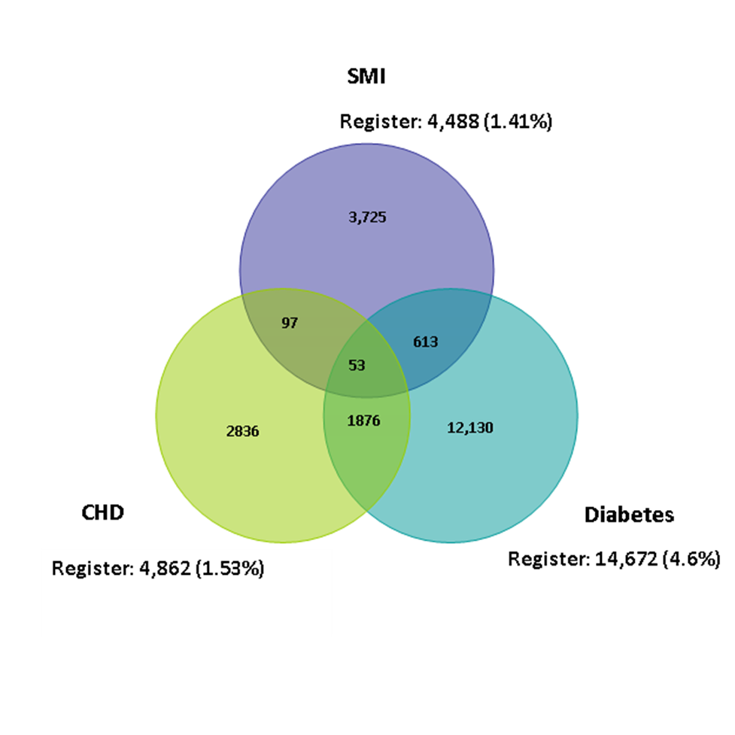

Based on estimates for the UK as a whole, we estimate that there are about 11,000 adults in City and Hackney with a personality disorder, such as borderline personality disorder and antisocial personality disorder (PD). People with PD may have other problems in their lives, such as alcohol and drug misuse, and will overlap with the ‘complex need’ group (see below).

Taking all these groups together, 6,490 people in City and Hackney with severe and enduring mental health problems entered secondary care services in 2017-18, of which 1,089 were inpatients on the acute wards or Psychiatric Intensive Care Unit (PICU). Service use by people with severe and enduring mental health problems is captured in the diagram below.

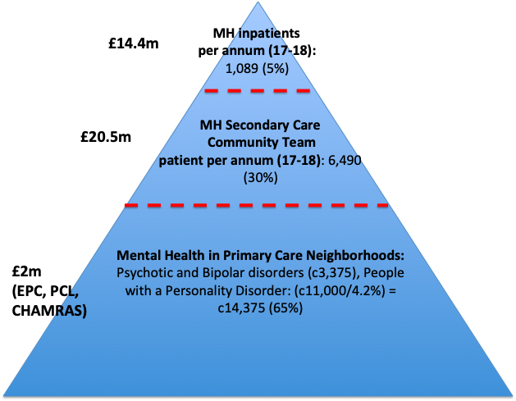

It is assumed that most people with a personality disorder will be within the primary care setting. We have not included people with severe and enduring anxiety and depression in primary care within this data set, but this is also a significant number.

People with SMI often have other challenges in their lives, including lack of employment, financial problems, issues with benefits and housing problems.

Employment rates are lower for people with mental health problems, than for any health condition. Rethink estimates that only 43% of all people with mental health problems are in employment, compared to 74% of the general population. Only 8% of people with schizophrenia are in work. Most people with mental health problems say that they want employment. People with SMIs are also over-represented in the homeless population (see below), while others may find themselves in insecure or inappropriate accommodation.

**Complex needs and undiagnosed mental health problems**

A national report estimates that there are around 58,000 people across England experiencing severe and multiple disadvantage involving substance misuse, homelessness and/or contact with the criminal justice system. Over half (55%) had a diagnosed mental health problem and nearly all (92%) had a self-reported mental health issue. This group can find it difficult to get the holistic help they need to address their needs, and may be ‘bounced between’ services - e.g. mental health and substance misuse services.

***Drug and alcohol misuse*.** UK studies suggest that the prevalence of co-existing mental health and substance misuse problems in mental services is between 32% and 46%. In City and Hackney, 386 people who started drug and alcohol treatment in 2017-18 (over 40%) had a mental health treatment need. Over a third (37%) of them were receiving no treatment at all, with 20% engaging in specialist services, and 42% receiving treatment from their GP.

***Homelessness.*** 80% of homeless people in England have a mental health problem, with 45% diagnosed, according to the Mental Health Foundation. In Hackney in 2017-18, 58 of 118 rough sleepers who were assessed (49%) had mental health needs; the equivalent figure for the City of London was 151 of 265 (57%). 58% in Hackney and 47% in the City of London had alcohol treatment needs. The respective figures for drug treatment need were 49% and 51%. Only 15% of the street homeless population across City and Hackney had no identified alcohol, drug or mental health needs.

***Crime and offending.***HM Chief Inspector of Prisons Annual Report 2017-18 concluded that 79% of women and 71% of men in prison said they had mental health problems. The majority of prisoners who are drug dependent have a least two mental health problems. A significant proportion of police time and resource is spent dealing with mental health related problems, including the detention of people in crisis for assessment under s. 136 of the Mental Health Act.

***Mental health and physical health comorbidity.*** Mental health problems may be undiagnosed and untreated where people present to health professionals with unexplained physical symptoms. In City and Hackney there are currently 272 people who have attended hospital A&E services ten times a year or more without a clear physical causation, over 3,000 A&E attendances. The pressure on A&E services could be alleviated and outcomes improved if these frequent attenders were receiving appropriate psychological, emotional or practical support. Additionally there are 15,169 patients in City and Hackney who have diabetes, of which 2,471 (18%) have uncontrolled diabetes as they are unable to manage their long term condition. This cohort may also benefit from appropriate psychological emotional or practical support.

**Children and young people’s mental health.**

City and Hackney has a relatively young population that has grown significantly in recent years, and will continue to grow. This is an ethically and culturally diverse population, with significant variations in levels of affluence and deprivation.

Compared to similar areas of London, Hackney has significantly higher numbers of children and young people with Special Education Needs - including more with Social, Emotional and Mental Health Needs - more looked after children, more in Pupil Referral Units and more 16-18 year olds who are not in education, training and employment. While the number of vulnerable children and young people is relatively low in the City of London, this includes some with high risk of emotional and mental health problems - for example, looked after children in the City of London are generally unaccompanied asylum-seeking children.

Across City and Hackney in 2017-18 (check) 49 children and young people required inpatient care, over 2,000 received specialist support in the community, and nearly 6,000 were treated for a diagnosable mental health problem by their GP. **NOTE: JG to add in non NHS spend/ GC to add in data on exclusion rates etc. 07 02 19**

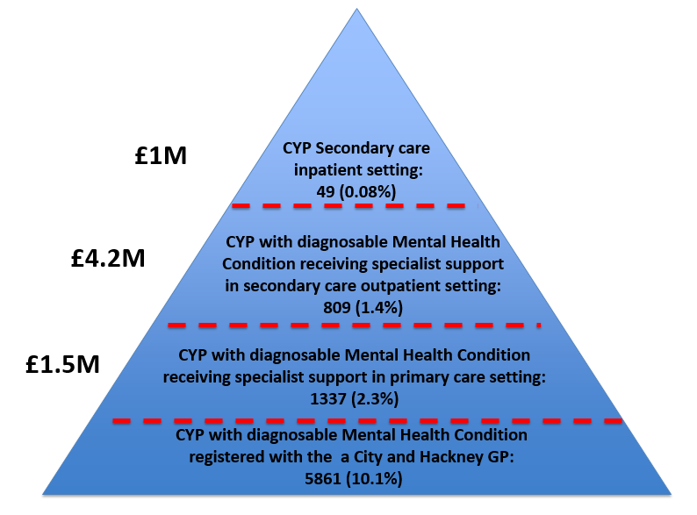

**Dementia**

Dementia is one of the main causes of disability in later life. It is characterised by progressive memory loss, behavioural and personality changes, impaired reasoning and ability to care for oneself. In the later stages, people become increasingly frail, may have difficulty eating and swallowing, experience incontinence and lose communication skills, including powers of speech, and become increasingly dependent on others. This also impacts the emotional wellbeing and mental health of carers.

It is estimated that approximately 1,300 Hackney and 90 City of London residents aged 65+ have dementia. Around half of those affected have their condition recorded by their GP. In addition, 40 Hackney and City residents *under* the age of 65 have dementia recorded by their GP. These residents are almost all aged 50-64.

Assuming the prevalence of dementia remains the same, the number of people living with dementia in Hackney is expected to increase by one third between 2015 and 2025, from 1,200 to 1,700. The number of people with dementia in the City of London is expected to more than double in this period, from 90 to 190.

Hackney has high rates of dementia detection, compared to both London and England. The diagnosis rate for January 2018 was 71.2% again a target of 66.7%.

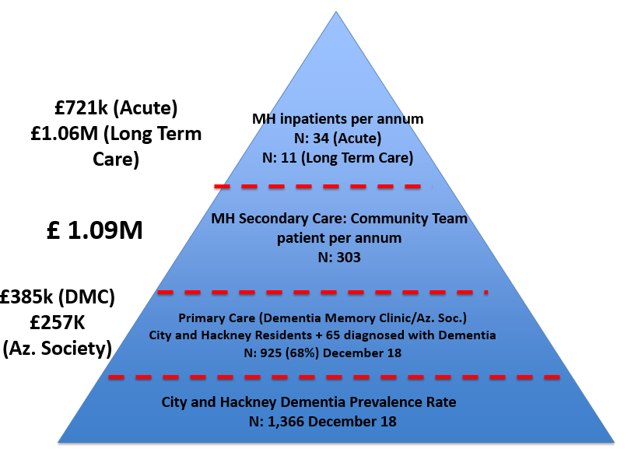

**Appendix 2: City and Hackney CAMHS Transformation Plan (Phase 3): Implementation (2019-20)**

**Executive Summary**

Our vision is that by 2020/21 we will have in place a system that meets the mental health needs of every child in City and Hackney. There will be no thresholds and no wrong doors. The system will exist beyond traditional health care settings extending in to schools and the wider community. It will be seamless and child / family centred, continually adapting through local service user empowerment and engagement. It will be optimised to catch mental health issues as early as possible preventing long term mental problems developing or escalating. Every intervention given will be supported by the robust evidence as every service becomes part of the CYP IAPT Programme. In doing so, it will be highly cost effective, making best use of every penny spent.

City and Hackney has a relatively young population which has grown significantly in recent years and is projected to continue to grow. The City of London and London Borough of Hackney are both ethnically diverse and are projected to become increasingly diverse with extreme variances in levels of deprivation across the area. Although children in City and Hackney are reporting relatively good levels of happiness there are a number of underlying issues that make it stand out from similar local authorities in London. Hackney has significantly higher numbers of children in SEMH and Pupil Referral Units. It has higher proportion of children with Special Education Needs (SEN), 16-18 year olds who are not in education, employment or Training (NEET) and looked after children. These children are likely to have increased mental health need when compared to others.

City and Hackney has a relatively high quality and comprehensive provision of CAMHS available to all children and young people in the area. The CCG has historically invested significantly in CAMHS and this investment continues to grow through the CAMHS Alliance and CAMHS Transformation Programmes, both of which are transformational. The CAMHS Transformation Programme is now entering Phase 3. The first phase is now operational with a recurring investment of £526,769 addressing previously identified gaps locally and in alignment with Future in Mind. Phase 2 and 3 represents on overarching whole-system strategy to improve mental health and wellbeing outcome for children and young people through 18 comprehensive workstreams representing additional investment of £1.2M in to children’s mental health:

1. Schools, Education, Training and Employment

2. Transitions

3. Crisis and Health Based Places of Safety (HBPoS)

4. Families (previously parenting)

5. Core CAMHS Pathways

6. Communities (previously Reach and Resilience)

7. Youth Offending

8. Eating Disorders

9. Perinatal and Best Start

10. Safeguarding

11. Early Intervention in Psychosis

12. Primary Care

13. Wellbeing and Prevention

14. Physical Health and Wider Determinants

15. Quality and Outcomes

16. Digital and Tech

17. Workforce Development and Sustainability

18. Demand Management and Flow

The table below provides a summary of CAMHS investments increases from 2014/15 baseline. CAMHS transformation represents an increase of £1.7m.



This local increase in investment equates to significant increase in front line clinical staff providing direct interventions

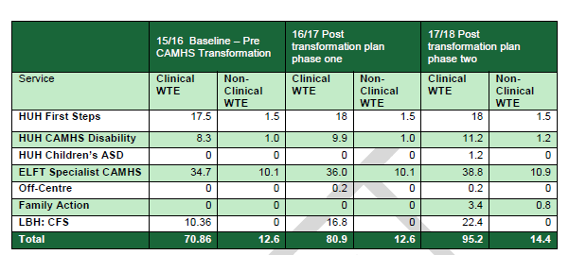

Increased capacity has allowed us to increase the number of new CYP seen per year and meet increasing demand

