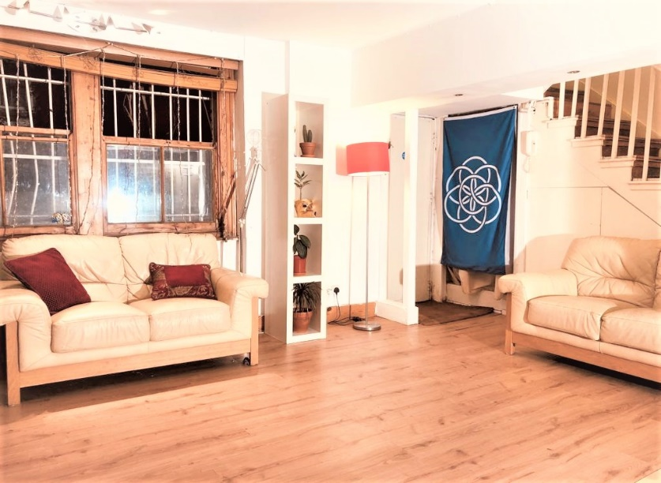
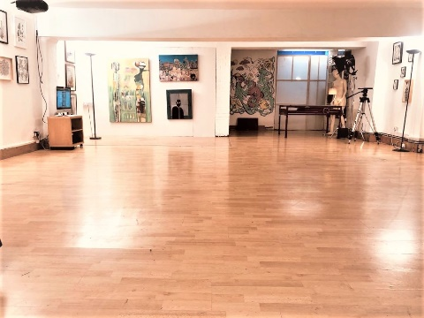
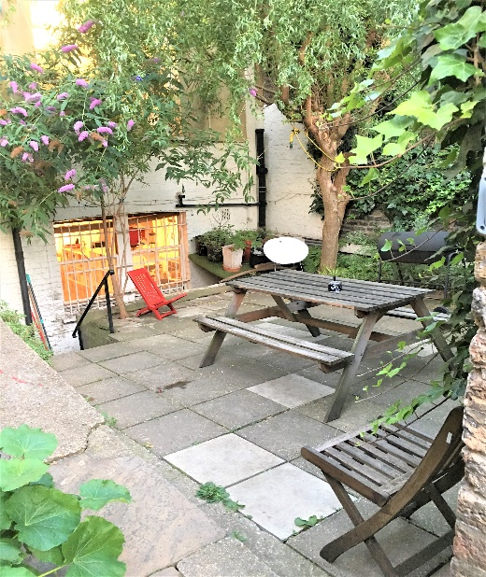
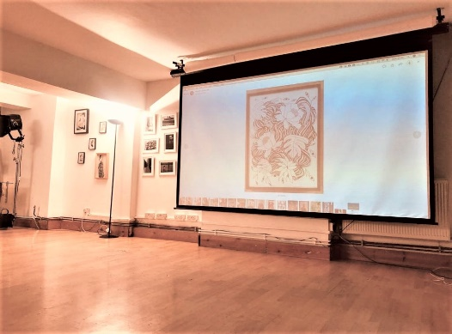
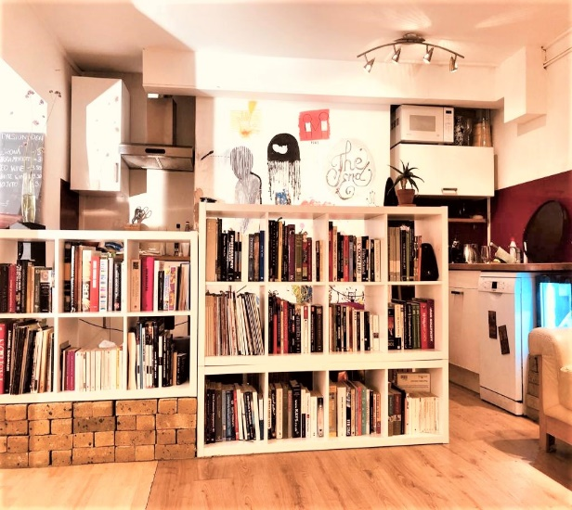
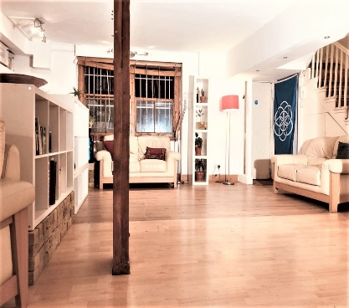
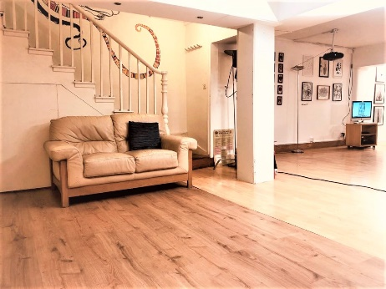
DALSTON DEN 89A KINGSLAND HIGH STREET E8 29B910
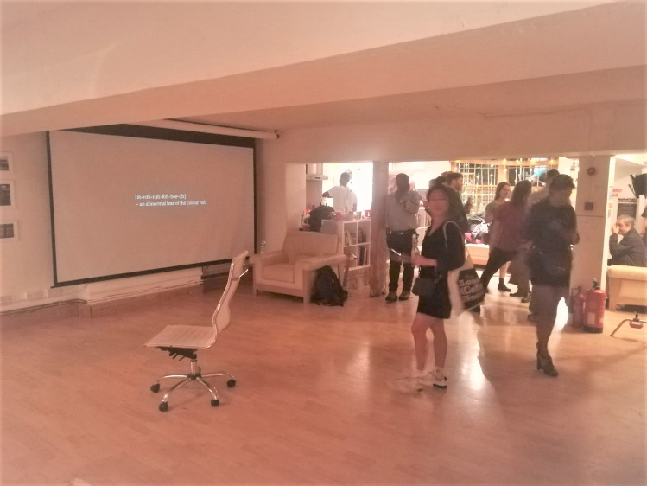
ABOUT DALSTON DEN
89A Kingsland High Street London E8 2PB
A large open studio (153 Square metres) in the heart of Dalston with a wooden sprung dance floor. The main area has been purpose made for activities such as dance, film and photography shoot, yoga, seminars, public events, art exhibitions, and rehearsals. Maximum capacity is for 100 people. The space also leads out on to an open garden area (42 Square metres) which can be used as a chill-out spot or breakout area.
Kingsland High road contains many cafes, shops, pubs as well as a sizeable Sainsbury’s, Waitrose and many more supermarkets. The venue can be conveniently accessed via the Dalston Junction, Kingsland over ground and many local bus

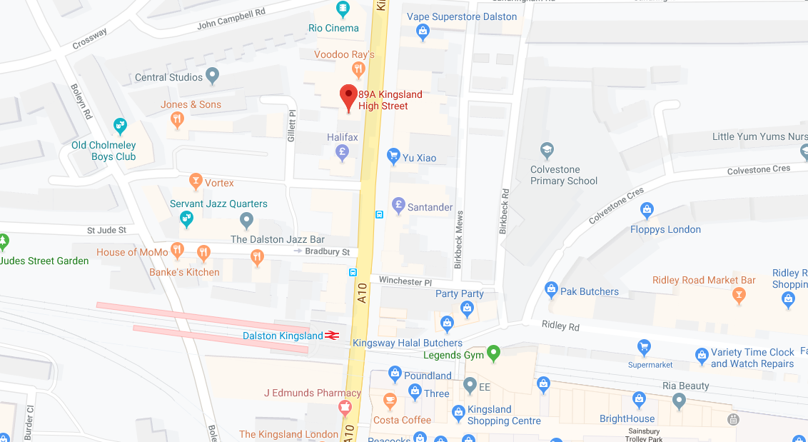
Daily rate - £150
Hourly rate - £30

For more info and bookings, please contact
info@840arts.com
07800594201
07811177136
07867339010

