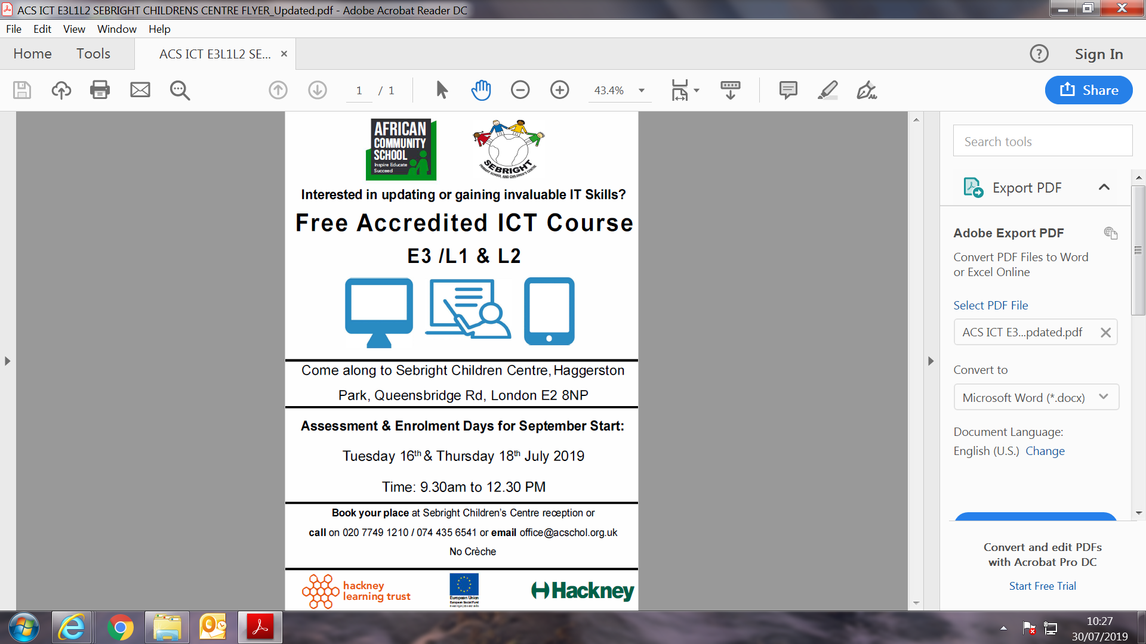

**Start from 3rd Sep 2019**

**Every Tuesday and Thursday**



**Start from 3rd Sep 2019**

**Every Tuesday and Thursday**