Introduction to Playwork- Entry level course
The Play Way Course - 18th and 19th July 2017
HPA- Homerton Grove Adventure Playground, E9 6BX - 9.30am-2.30pm

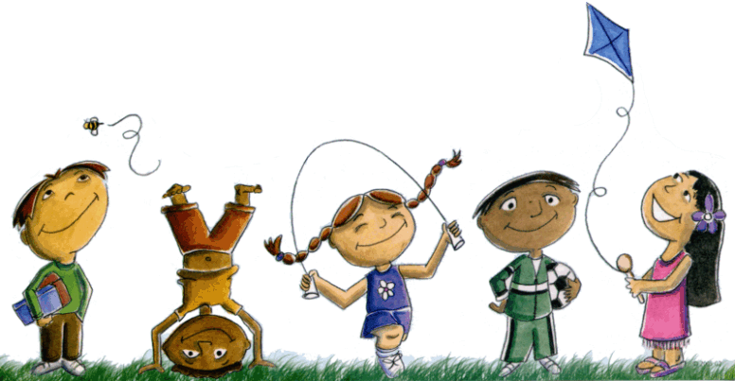

This short course, (2 days) is aimed at staff who are new to playwork, will be running in the spring term, the sessions covered are basic playwork principals, role of a playworker, recognising risk and benefit. It is a very practical, accessible and fun course, ideal for those new to playwork. The costs are £60 per person for the complete course.

We will also be offering short courses for playworkers on , Promoting Positive Behaviour, Outdoor activities, Creative Ideas , subject to demand. They cost £20 for Hackney groups and £25 for non-Hackney groups. Please contact kay@hackneyplay.org to book places and to get more information.

