Premises survey headline data
Summary
- 61 respondents
- 70% of these have a base I Hackney (42 organisations)
- 40 respondents have an income over 50,000 (20 of these income over 350,000)
- 12 respondents renting privately
- 6 organisations have leases under 3 years and 8 have no lease in place
- 12 organisations report premises costs unaffordable
- 14 organisations report rent increases in last 5 years
- 9 organisations report rent is 10-20% of their annual turnover
- 9 organisations report rent is above 20% of their annual turnover
- 20 organisations plan to move in next 5 years
- 14 organisations have insufficient office space
- Between 24 – 29 organisations interested in collocating
Section 1 Sustainability and Affordability
Type of Tenure
26% of respondents are renting privately (12 organisations)
7 organisations own their premises
1 organisation is colocated with the statutory sector
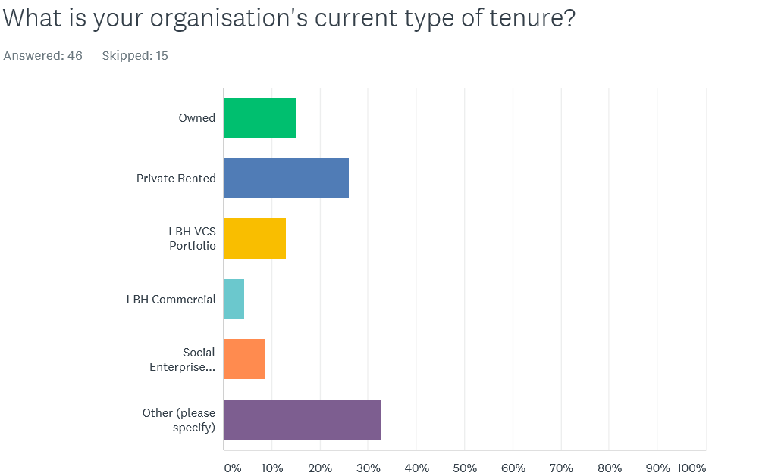

Length of Lease
1 organisation has a 7 year lease. 4 have a 5 year lease and 5 have a 3 year lease. 6 organisations have leases under 3 years. 8 organisations report having an expired lease or no lease in place. 3 organisations have a lease of 10 years plus.
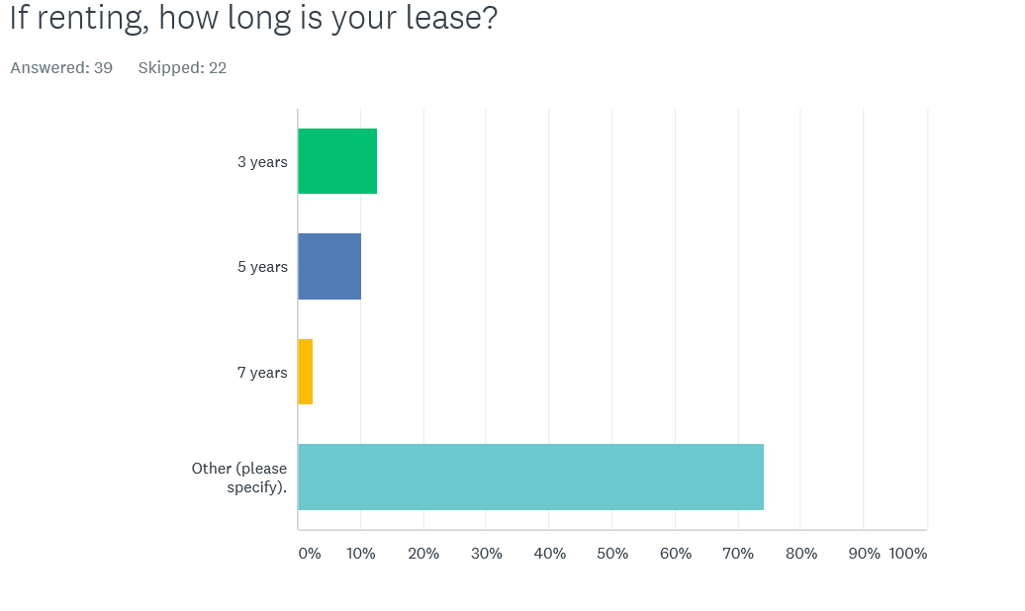
Class of property
20% (10 organisations under office space)
47% (23 organisations) under public services – community / health / education
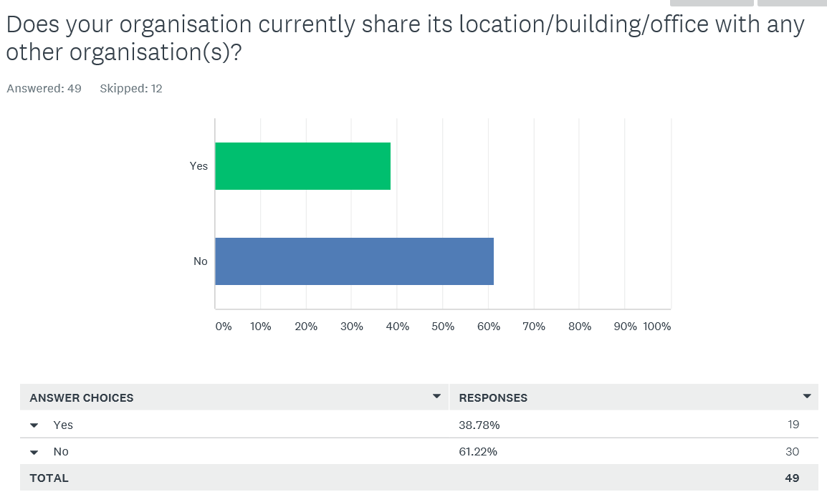
Are your premises costs affordable
12 organisations reported their premises costs were unaffordable – (26%)
34 organisations reported they were affordable (74%)

Rent Increases
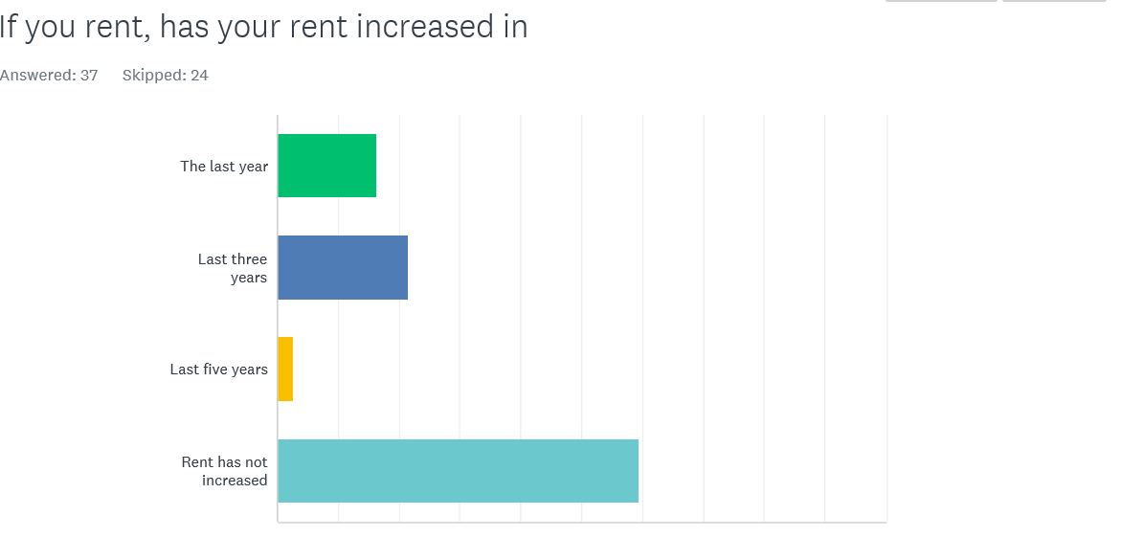
6 organisations report their rent has increased in the last year, and 8 in the last 5 years.
22 organisations have not experienced a rent increase.
What percentage of your annual income goes on rent

Do you plan to move premises

15 organisations plan to move in the next year and 5 in the next 3 years
32 organisations do not plan to move
Of the 20 organisations planning to move
5 want to move because of cost of rent, 15 because the space does not meet their needs and 12 because they are planning to expand activity

Section 2 Suitability of premises and potential for co location

17 organisations lease allows them to sublet – 37 organisations cannot sublet according to their lease

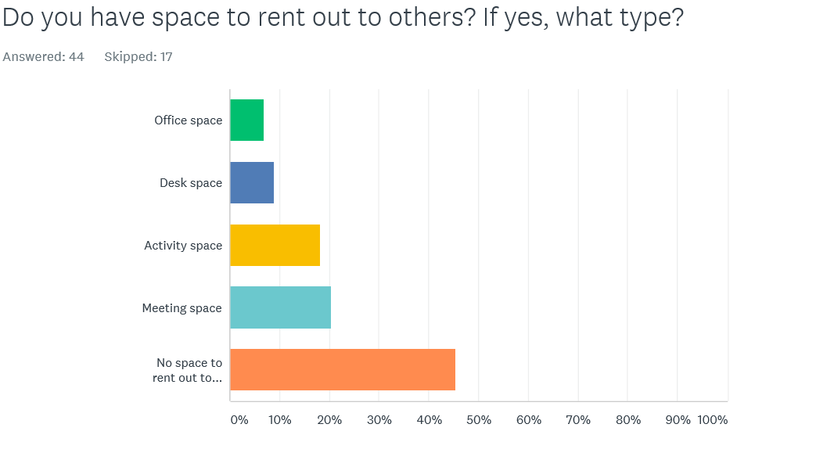

Does your organisation have sufficient space and resources ?
A total of 54% of respondents report having insufficient office or delivery space
45% of organisations reported having sufficient space and resources
14 organisations have insufficient office space (30%)
11 organisations have insufficient project delivery space (24%)
9 organisations have insufficient IT infrastructure - 20%
6 organisations have unsuitable office space
4 organisations have unsuitable delivery space
Co-location of space
41% (24) of respondents are interested in co-locating with either statutory or VCS services
36% (21) with VCS organisations
14% (8) with statutory organisations
18 organisations provided details so we can follow up with them.
Who would you want to co-locate with
Advice/advocacy | 9.09%  4
–  Disabilities services | 4.55%  2
–  Domestic violence and sexual violence support | 4.55%  2
–  Equality and diversity | 2.27%  1
–  Mental health support | 11.36%  5
–  No preference | 15.91%  7
–  Older persons services | 4.55%  2
–  Special educational needs | 2.27%  1
–  Youth services | 15.91%  7
–  Responses  Other (please specify) | 29.55%  13

Section 3 Who responded
What services do you provide
Advice/advocacy | 47.54%  29
–  At home care | 6.56%  4
–  Disabilities services | 19.67%  12
–  Domestic violence and sexual violence support | 9.84%  6
–  Drug and alcohol support | 9.84%  6
–  Equality and diversity | 19.67%  12
–  Financially disadvantaged/excluded | 21.31%  13
–  Gay and lesbian issues | 1.64%  1
–  HIV/AIDS services | 1.64%  1
–  Mental health support | 27.87%  17
–  Older persons services | 26.23%  16
–  Place/neighborhoods facing disadvantage and deprivation | 18.03%  11
–  Race equality issues/racial harassment and discrimination | 8.20%  5
–  Special educational needs | 19.67%  12
–  Socially isolated | 52.46%  32
–  Youth services | 31.15%  19
–  Responses  Other (please specify) | 37.70%  23
Total Respondents: 61

Who are your main beneficiaries
–  People affected by domestic violence | 1.67%  1
–  People from Black and Minority Ethnic Communities | 23.33%  14
–  People living with HIV | 0.00%  0
–  People over 65 | 10.00%  6
–  People under 25 | 21.67%  13
–  People with learning disabilities | 1.67%  1
–  People with mental health problems | 6.67%  4
–  People with physical disabilities | 5.00%  3
–  Women only | 5.00%  3
–  Responses  Other (please specify) | 25.00%  15
TOTAL | 60

