**FOR IMMEDIATE RELEASE**



**HACKNEY ARTS CHARITY CELEBRATES 30-YEAR**

**ANNIVERSARY WITH EXHIBITION**

This exhibition by artists from the therapeutic arts community Studio Upstairs celebrates 30 years of the diverse creativity and artistic skills of the Studio members, team and volunteers.

The charity Studio Upstairs was founded in 1988 to meet the needs of people moving out of the psychiatric health system, by providing a supportive community-based environment somewhat removed from the conventional clinical setting, where members can communicate their experiences through making art. It is now celebrating its 30th year in London, has a branch in Bristol, and has recently opened in Croydon.

The exhibition will showcase work from members of the Studio Upstairs past and present and includes painting, print, sculpture and digital media.

**Artist Statement:** ‘As artists, we make art to explore our experiences of everyday life and use them as raw material in the creative process. In doing so we can make these experiences understandable or acceptable to ourselves and to the world outside.’

‘Studio Upstairs is a space to take some joy in colour, texture, and making art. For those of us who struggle to find a way to be with ourselves and others, this can the breathing space we need.’

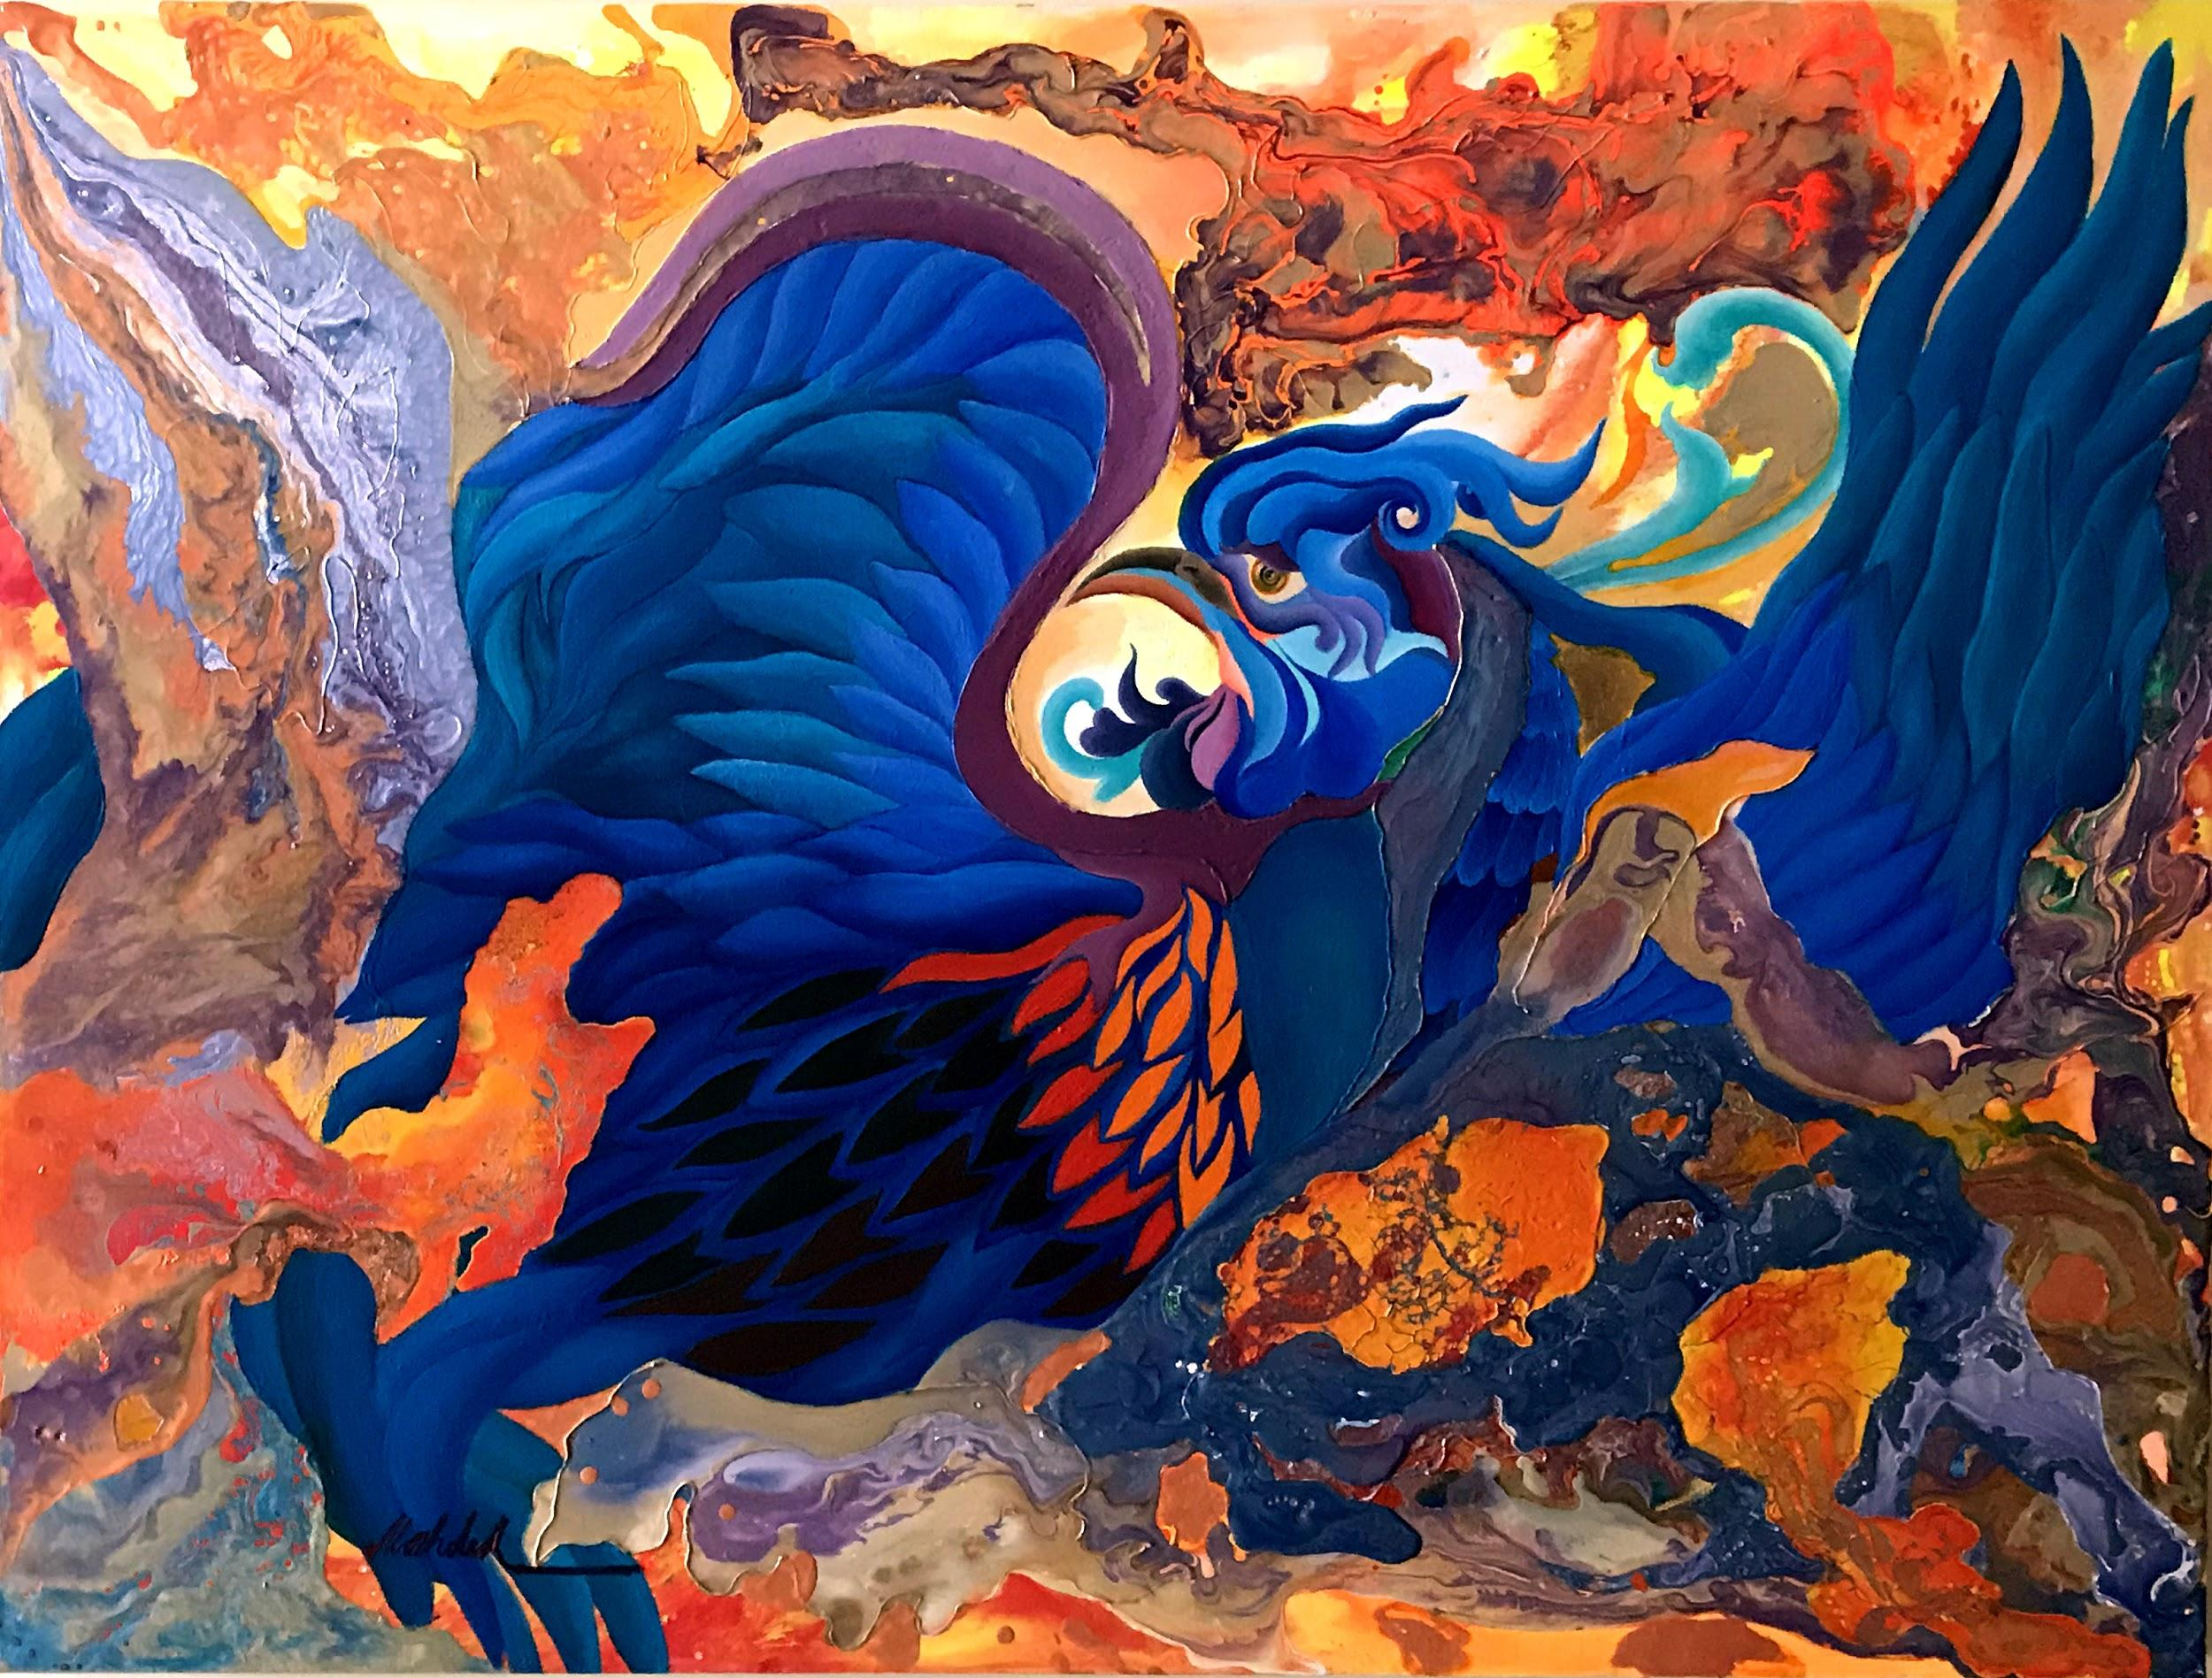

Artwork by Tahere Mozhdeh Nazirpour

Huma, (Bird-of-paradise)

100cm x 70cm Acrylic Painting on Canvas

Zlatinka Hristova, Director of Studio Upstairs, says: “This exhibition is an opportunity for us to celebrate the resilience of the charity and the impact that it has made to many individual lives over the past 30 years, allowing the artists to tell their own story through their artwork”

The charity’s patron, Leo Burley, a documentary film-maker who directed the Bafta-nominated BBC documentary, Life After Suicide, says: “I cannot emphasise enough the significance of giving individuals access to mutually supportive group environments and creative opportunities can make in improving people’s long-term mental health. The work of Studio Upstairs is crucial in helping some of the most vulnerable people in our society become empowered through making art.”

**STOUR SPACE**:

Studio Upstairs has partnered with Stour Space, Hackney, a socially minded organisation offering exhibition, performance and studio space for the development of creative enterprises. Devoted to the promotion and production of art and design, performance and innovative business, Stour Space also works in collaboration with many local enterprises, residents, artists and committees.

**EDITOR’S NOTES**

Studio Upstairs is an arts and health charity with branches in Bristol and London. Our vision is for a world in which everyone can transform their life through creative community. We provide positive, life-changing interventions for people with mental or emotional difficulties within an artistic therapeutic community. We will support you to enhance your well-being and health, reinforce and recharge your creativity and achieve your own goals.  
<http://www.studioupstairs.org.uk/>

**CONTACT**

Zlatinka Hristova

[Zlatinka.hristova@studioupstairs.org.uk](mailto:Zlatinka.hristova@studioupstairs.org.uk)

Telephone: 020 8616 5440

Adam Steiner **Coordinator**

[adam.steiner@studioupstairs.org.uk](mailto:adam.steiner@studioupstairs.org.uk)

Telephone: 020 7503 1330/ 07988280377

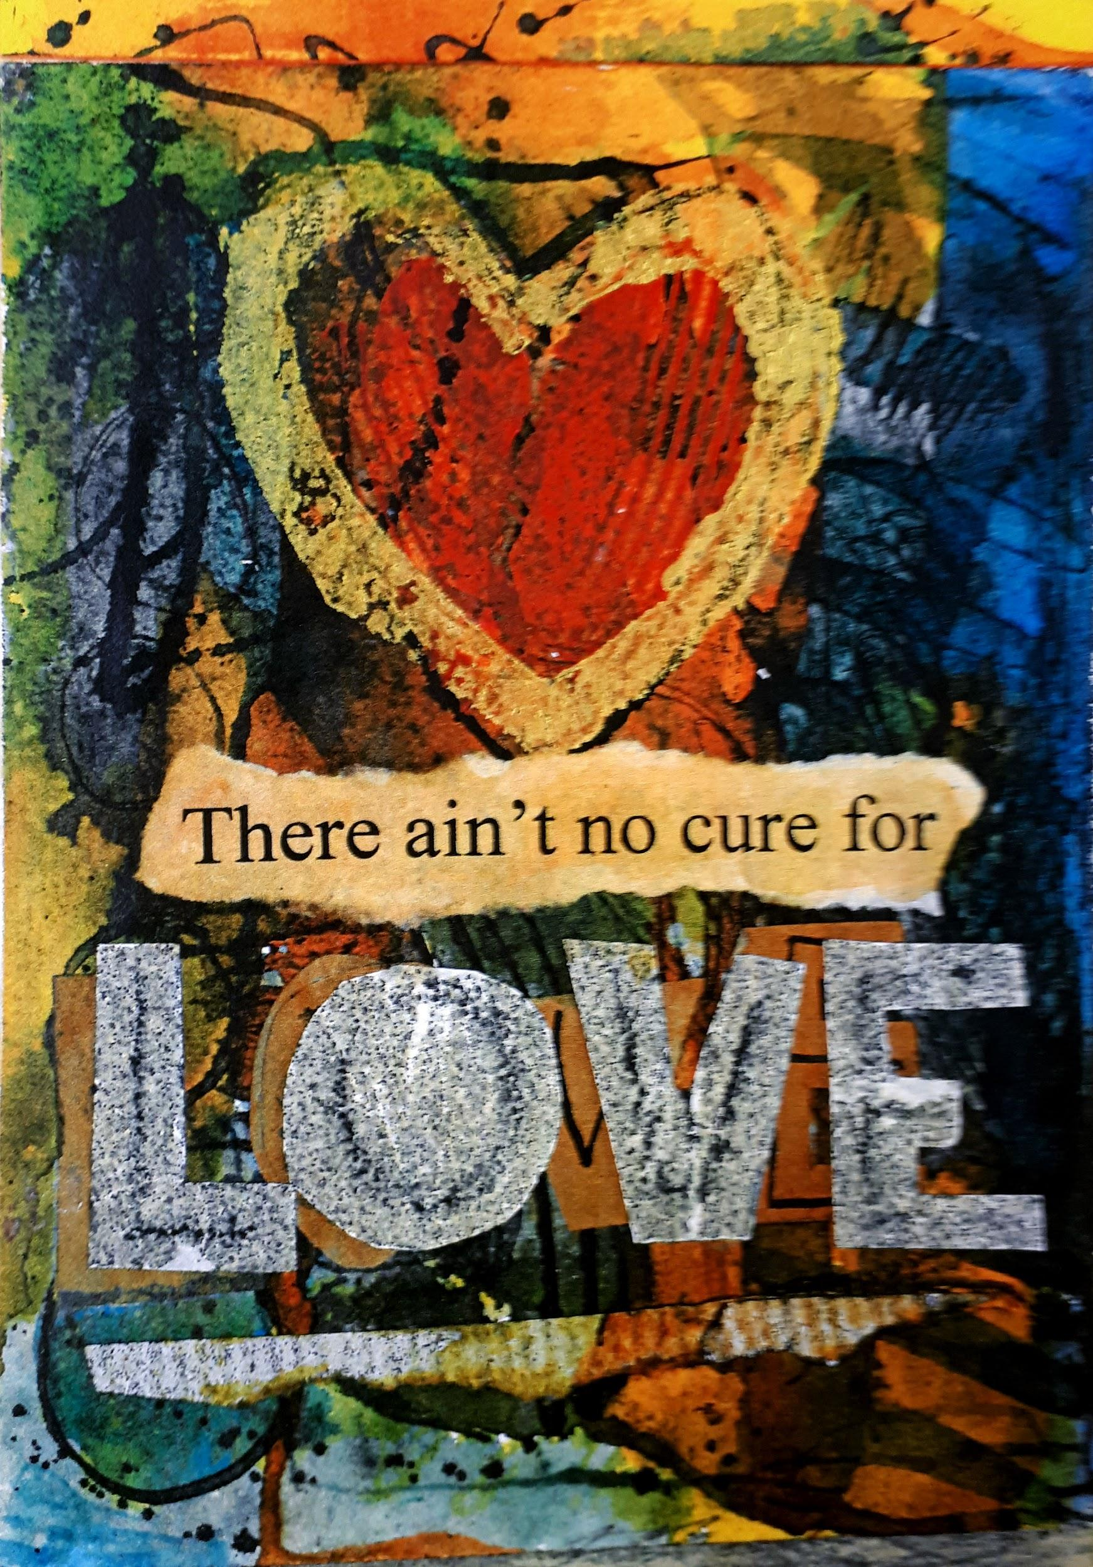

Artwork by Andrew Mead

Mixed media

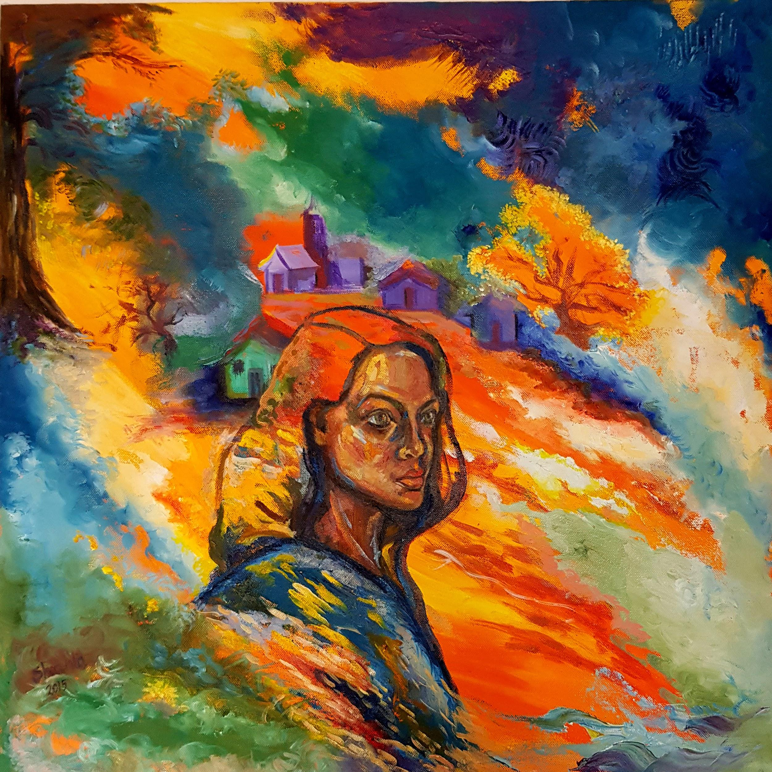

Artwork by Shahla Isfahani. Acrylic and oil paint on Canvas, 60cmx60cm

Artwork by Patsy McMahon. Untitled, Mixed media