City & Hackney Health & Social Care Forum (HSCF)

Health and Social Care Transformation
Voluntary & Community Sector (VCS) Representatives
Application Pack

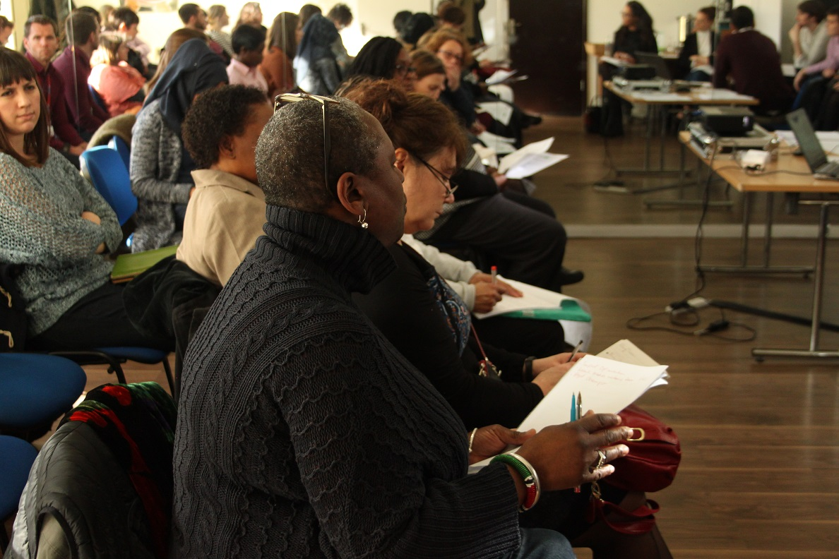

A Short Guide to Integrated Commissioning

Integrated Commissioning is the name of the process that is happening in Hackney and The City at the moment, which is where Health and Social Care are coming together so that they can provide better services to people in Hackney and The City, and so that they can save money.

There are lots of different organisations involved in Integrated Commissioning, including:
City and Hackney Clinical Commissioning Group, Homerton Hospital, the East London Foundation Trust, Hackney Council and City of London Council.

Sustainability and Transformation Plan

The aim of STPs is to ensure that health and care services are based upon the needs of local people. STPs bring together NHS providers, Clinical Commissioning Groups, Local Authorities and other health and care services to provide health and social care in a certain area. The STP in North East London is called the East London Health and Care Partnership, and it covers Barking & Dagenham, City of London Corporation, Hackney, Havering, Newham, Redbridge, Tower Hamlets and Waltham Forest.

An Accountable Care System is a group of providers who fund services together to make sure that the services available suit the area and people who live there.
There will be three Accountable Care Systems in North East London.

Integrated Commissioning Board
This is the name of the Board that controls all the different work that is happening across City and Hackney that will mean that all the providers (the Clinical Commissioning Group, Homerton Hospital, the East London Foundation Trust, Hackney Council, City of London Council and more) can work together to use their money to provide services that suit the people who live in City and Hackney. Also, it will mean that they will be able to save money by working together which they need to do as there is less money available for services at the moment.

There are four main areas of work in City and Hackney:

Planned Care

Unplanned Care

Prevention

Children, Young People and Maternity Services
There are also lots of different, smaller groups that are working on issues such as integrated care, supported employment, mental health, and many more.

The Role

Health and Social Care Forum Representative on the Engagement Enabler Group

Health and Social Care Representatives work to represent the Voluntary and Community Sector on the various Boards, Groups and Workstreams that are part of Integrated Commissioning. They do not need to be experts in the area that they are representing, but they do need to understand or learn where to get information from so that they can understand the area they represent, and share information from Integrated Commissioning with the Voluntary and Community Sector.

The Engagement Enabler Group has been set up to ensure that residents know about the changes that are happening to services as a result of Integrated Commissioning, and that their opinions on the changes are heard and listened to.

The role of the Representative is:
- To make sure that the Voluntary and Community Sector is represented at the meetings (which happen twice a month)
- To make sure that small groups, especially groups that represent the full diversity of Hackney, are represented at the meetings
- To feed back what happens at the meetings to the rest of the Voluntary and Community Sector, via Health and Social Care Forum meetings, Special Interest Groups, and Forum meetings

Person Specification
- To have a good understanding of the basics of Integrated Commissioning
- To be able to represent the Voluntary and Community Sector in meetings
- To have an excellent understanding of equality and diversity
- To be able to separate the needs of your organisation from the general needs of the Voluntary and Community Sector
- To be able to feed back to the Voluntary and Community Sector on what has happened at the Engagement Enabler meetings
- To be able to always treat other people with respect

The Commitment / Accountability

As these are the most important representative roles in the Health & Social Care Forum structure it requires a time commitment of approximately one day month. Please ensure that you have sufficient time, management backing and support from within your own organisation.
Specific commitments we require of the representative are:
- To attend all of the Board/ Workstream meetings in the year (twice a month) or to give notice to arrange cover
- To attend 75% of HSCF Steering Group meetings (monthly meetings) per year.
- To attend a Special Interest Group at least once per year
- To attend 75% of HSCF Forum meetings (four times a year)
- To attend 75% of cross network meetings (four times a year)
- To post on Trello the main points of the agenda to the forum for comments and to take HSCF members comments to share at the meeting.
- To work in partnership with the Children and Young Peoples Providers Forum and Hackney Refugee Forum, Safer Young Hackney and the LGBT+ networks to ensure that Voluntary Sector and Community Group issues are represented
- To work in partnership with Healthwatch Hackney to ensure that service users issues are represented
- To build good relationships with people at the meetings and at the Health and Social Care Forum, but also to raise questions when an issue may be bad for service users or the Voluntary and Community sector
Confidential discussions:
You may sometimes be asked to take part in confidential discussions at meetings. When this happens please let the Steering Group know the topic of the discussion, even if you cannot let people know exactly what is being discussed.
Support & Expenses
To be followed
Application process:
Please send an expression of interest
An informal interview will be held on

