

**City & Hackney Health & Social Care Forum (HSCF)**

**Health and Social Care Transformation**

**Voluntary & Community Sector (VCS) Representatives**

**Application Pack**

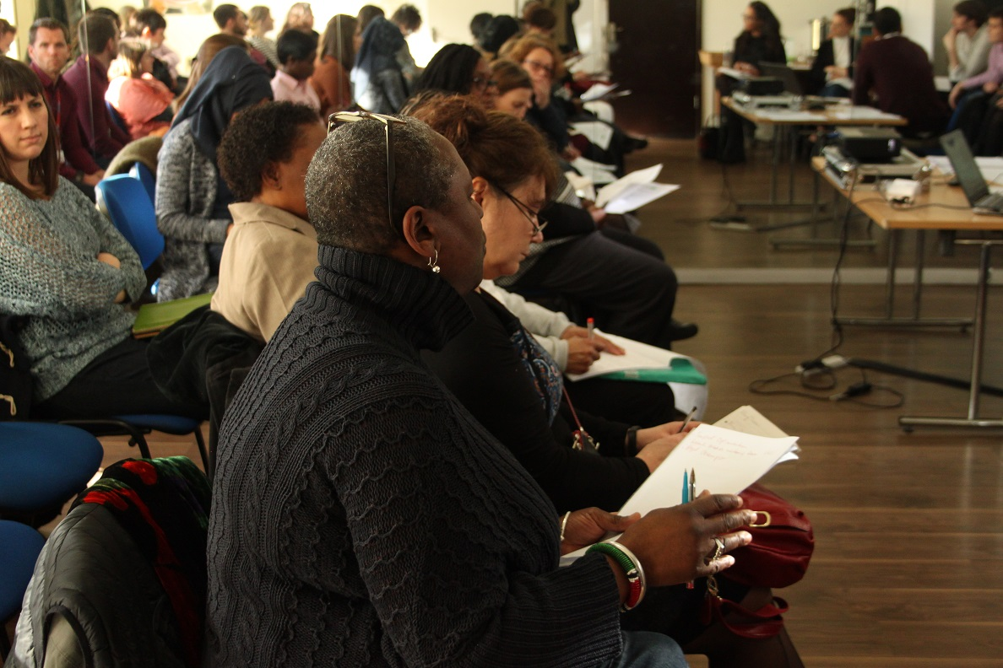

**Contents**

**Section 1 Context**

Health and Social Care Transformation

Hackney Integrated Commissioning Board

Hackney & City Transformation Board

Workstreams

**Section 2 Voluntary & Community Sector Representative Position**

Role: The Voluntary & Community Sector Representative on the Planned Care Workstream

Additional Information for All Roles

Application Process

**Section 3 About the Health and Social Care Forum**

The Health & Social Care Forum

The Structure and Role of Health and Social Care Forum meetings

**Section 1 Context**

1. **Health and Social Care Transformation**

Health and Social Care Transformation is a local partnership to improve health and wellbeing outcomes for Hackney and City of London residents through closer joint working and integration between local health and care organisations. The programme is about:

* Transforming and joining up health and social care services around people to better meet their needs and ensure they have the healthiest lives possible.
* Supporting people to take a more active role in their own health and in shaping future services.
* Making the most of the joint knowledge, expertise and resources available in Hackney and City by working together.
* Tailoring services to the unique needs of the respective diverse communities in Hackney and City.

The partners are the organisations that plan, buy, deliver and scrutinise health and care in Hackney and City:

* [City and Hackney Clinical Commissioning Group (CCG)](http://www.cityandhackneyccg.nhs.uk/)
* [City and Hackney GP Confederation](http://www.cityandhackneygpconfederation.org.uk/)
* Voluntary and community sector (VCS) via the City and Hackney Health and Social Care Forum (HSCF)
* [City and Hackney Pharmaceutical Committee](http://psnc.org.uk/city-and-hackney-lpc/)
* [City and Hackney Urgent Health Care Social Enterprise](http://www.chuhse.com/) (CHUHSE)
* [City of London Corporation](https://www.cityoflondon.gov.uk/Pages/default.aspx) (COLC)
* [East London NHS Foundation Trust](https://www.elft.nhs.uk/) (ELFT)
* [Hackney Council](http://hackney.gov.uk/) (LBH)
* [Healthwatch City of London](http://www.healthwatchcityoflondon.org.uk/)
* Healthwatch Hackney
* [Homerton University Hospital](http://www.homerton.nhs.uk/) (HUH)

Senior leaders from these organisations sit on a Transformation Board that oversees the joint work. We have a good record of working together and have been working to integrate health and social care for a number of years. The Hackney partners, with the City of London Corporation as an observer, also submitted a request to central government in 2016 for [devolution of health and social care](http://healthwatchhackney.co.uk/sites/default/files/uploads/Hackney_Devo_Business_case.pdf) that they are waiting to hear back on.

The structure below has been developed to enable the commissioners (CCG, Hackney Council, COLC) to pool and align budgets and to jointly plan local health and social care services with providers and service users. Integrating delivery of health and social care will build on the One Hackney & City pilot. This structure is one of the local delivery components for the [north east London sustainability and transformation plan](http://www.nelstp.org.uk) (NEL STP).

1. **Integrated commissioning**

An Integrated Commissioning Board (ICB) for Hackney is being set up to oversee a pooled budget (CCG, Adult social care and Public Health) from April 2017 and decide how best to commission services for each local area.

The indicative budgets for the Hackney ICB based on 2016/17 budgets are:

|  |  |  |
| --- | --- | --- |
| **Budget holder** | **Pooled budget** | **Aligned budget** |
| CCG | £325m | £52m |
| Local Authority (LA) | £111m | £6m |
| Total: | £437m | £47m |

An ICB is also being set up for the City. Each ICB is made-up of locally-elected councillors, local NHS leaders and a public representative. Each board will be made up of two committees meeting who will operate in common - one from the local authority, and one from CCG - that will have authority to make decisions on behalf of their statutory organisation. Statutory responsibilities and accountabilities remain with the statutory organisations.

*Terms of reference for the ICBs and Transformation Board are* [*available here*](http://mginternet.hackney.gov.uk/documents/s53534/LBH%20Appendices%2016feb17.pdf) *but may be subject to change.*

**The Integrated Commissioning Boards (excerpt from the structure diagram above)**

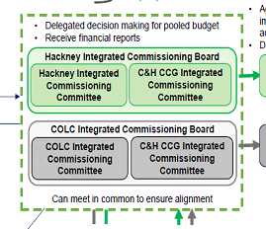

**Membership of the Hackney Integrated Commissioning Board**

*Membership of the Local Authority Committee*

3 Local Authority Councillors

*Membership of CCG Committee*

* Chair of the CCG
* CCG Governing Body Lay Member
* CCG Chief Officer

*Additional attendees*

* CCG Governing Body GP representative
* CCG Chief Financial Officer (CFO)
* LBH Group Director Adults & Children’s Services
* LBH Group Director Finance & Corporate Services

*Standing invitation*

* Director of Public Health
* Healthwatch
* VCS Representative – selected via HSCF
* Person nominated by CCG & LA CFOs

Standing invitation representatives on the Integrated Commissioning Board will not have voting rights but will be able to contribute to discussions (no terms of reference yet).

1. **Transformation Board**

The Transformation Board will:

* consider proposals put forward by different workstreams.
* ensure that the plans pull together into one system.
* advise and make recommendations for commissioning to the two Integrated Commissioning Boards.
* implement the decisions made by the Integrated Commissioning Boards.

The membership of the Transformation Board covers City and Hackney:

* CEO/Medical Director of main local providers
  + Homerton, ELFT, CHUHSE, GP Confederation
* Chair and Chief Officer of CCG
* Director of Public Health
* Director of Adult Services – LBH
* Head of Early Years – LBH
* Group Director of Neighbourhoods and Housing – LBH
* Assistant Director of Commissioning – COLC
* Assistant Director of People – COLC
* Healthwatch
* Voluntary & Community Sector Representative – selected via Health & Social Care Forum
* CCG Lay member for PPI
* LBH CEO – Chair

(Terms of reference available but may be subject to change)

1. **Workstreams**

This structure is supported by a number of workstreams which have or are in the process of developing a terms of reference.

**4.1 Care workstreams**

Four care workstreams will consider delivery of a range of integrated services in the following areas:

* Planned care,
* Unplanned care,
* Prevention,
* Children and young people.

Each will ensure they consider the City of London as a dimension when discussing and making recommendations on provision. In addition, mental health will be part of every care workstream to ensure it’s embedded. Each workstream will represent the system as a whole and be collectively responsible for:

* Management of pooled budgets.
* Management of performance.
* Development of Joint Health & Wellbeing Strategies.
* Improving outcomes.
* Ensuring delivery of local ambitions, plans and STP ambitions.
* Redesigning services and delivery where necessary to have a greater impact.

.

* 1. **Enabler workstreams**

A number of enabler workstreams are in place to ensure the infrastructure and systems are in place and relevant for the delivery of integrated health and social care services. Some are pre-existing groups and some were set-up during the development of the request for devolution of health and social care in Hackney.

**Estates:** The VCS representative is Paul Monks (Artistic Director, Core Arts). The group developed the business case for Hackney to have ownership of its estates. We are waiting for a response on this from central government.

**IT:** TheVCS representative is Alistair Wallace (Director, MRS Independent Living). This group is working to ensure IT systems in the partner organisations can communicate and information can be shared under the data protection act. It includes a funded VCS programme working with organisations to ensure they have the right database in place initially. For more information about this contact Mohammed Mansour on <Mohammed@hcvs.org.uk>

**Communications and engagement:** This group is working to ensure patients, residents, staff, and the VCS are informed, engaged and involved in transforming services in partnership with clinicians and practitioners. It is also making sure communications are clear and consistent. The group’s terms of reference are currently being reviewed. The current VCS representative is Jackie Brett, Director of Communities & Partnerships, Hackney CVS.

**Workforce:** This group predates devolution and the transformation structure and has no VCS or patient/public involvement. It is looking at developing integrated and specialist roles to meet the changing needs of the population.

**Organisational development:** This group will support staff at the partners with new ways of working.

**2. Voluntary & Community Sector Representative Position**

**Role 1: The Voluntary & Community Sector Representative on the Planned Care Workstream**

The Structure of the Transformation Board and the Integrated Commissioning Board is supported by 8 subgroups which each have or are in the process of developing a Terms of Reference. Four of the eight subgroups are defined as ‘Workstreams’ and their role is to consider delivery of the range of integrated services around Planned Care; Unplanned Care; Prevention; and Children & Young People. The second four of the eight subgroups are defined as ‘enabler groups’ and their functions is to ensure that the infrastructure and systems needed to enable the delivery of integrated health and social care services are in place and relevant. These are Estates; IT Enablers; Communication and Engagement; and Workforce Development.

The Planned Care Workstream works on an Associative Member model, and as such the Rep would attend the Core Group as and when requested to do so.

Purpose of the Planned Care Workstream is to represent the system and be collectively responsible for:

* Management of pooled budgets for planned care related activity;
* Management of performance of planned care related activity;
* Development of Joint Health & Wellbeing Strategies;
* Improving outcomes;
* Ensuring delivery of local ambitions, plans and STP ambitions across Planned Care related activity;
* Redesigning services and delivery where necessary to have a greater impact across the Planned Care agenda.

It is expected that this role will provide a voice for the sector around:

* High level development of responses and system re-design for the full Planned Care programme of work across the sector and partners;
* A Co-ordinated response from the sector to policy and process for Planned Care agenda of health and social care across the borough
* Present options for participation of the Sector within each of the main functions of the Board
* Ensuring discussion, decisions and information from the PCWB are publicised across the sector through the Health & Social Care Forum; communication channels including newsletters; email correspondence and inclusion on the H&SCF website;

The scope of Planned Care is wide, however their main areas of focus are expected to be:

* Mental health
* Anti-coagulation pathways
* Continuing Care: cancer pathways
* Residential/supported housing schemes

The core elements of each of the roles are to:

1. Attend monthly and participate in the Planned Care Workstream board. Papers will be circulated prior to meetings; attendance at this meeting in as the Representative of the Third Sector rather and therefore the expectation is that whoever fills the role will not be an ‘expert’ in all fields. It is therefore crucial to ensure regular communication with partners across the sector; the Policy Lead from HACKNEY CVS and other lead Reps through:
   1. Attendance the HSCF Steering Group (monthly meetings), Special Interest Group (quarterly) and Forum meetings (quarterly) to ensure that you understand the diversity of Health & Social Care Voluntary & Community Sector issues:
   2. Contributing to briefings to the wider sector on Planned Care Workstream Board PWB), the discussions and decisions taking place at the PCWB and the likely implications for Third Sector Organisations operating across the Health and Social Care Sector; :
   3. Attend and participate in pre-meeting with voluntary and statutory sector partners as required:
   4. Attend cross network executive meetings to look at issues that affect the Voluntary & Community Sector across the piece (quarterly):
2. Feedback at meetings and via the newsletter issues coming up at the meetings:
3. Attend monthly and participate in the board or workstream:
4. Attend and participate in pre-meeting with voluntary and statutory sector partners as required:
5. Foster good relationships with statutory and VCS and patient / public partners:

**Person Specification**

1. Understanding of the background, role and potential of the Transformation of Health and Social Care to improve the health and wellbeing of Hackney residents through reducing health inequalities, better working relationships across all sectors;
2. Understanding of national and local policy drivers for health and social care service delivery;
3. Experience of strategic management and commitment to advancing and supporting the purpose of strategic partnership;
4. Active commitment to and ability to progress partnership working and networking;
5. Active commitment to promoting equality and diversity underpinned by a clear understanding of the link between inequality and disadvantage and how policy decisions can impact on diverse and disadvantaged communities;
6. Ability to separate own organisational needs from the needs of the Forum;
7. Ability to consult, use this information usefully, and to feedback on discussions;
8. Ability to productively and positively raise issues of concern to the Voluntary & Community Sector both in meetings and in pre-meeting work;
9. Commitment to the independence of the Voluntary Sector in purpose, voice and action;
10. Ability to consistently treat other people with respect and be aware of the way in which you communicate with other people and your impact on them;

**The Commitment / Accountability**

As these are the most important representative roles in the Health & Social Care Forum structure it requires a time commitment of approximately one day month. Please ensure that you have sufficient time, management backing and support from within your own organisation.

Specific commitments we require of the representative are:

* To attend all of the Board/ Workstream meetings in the year (monthly) or to give adequate notice to arrange cover.
* To attend 75% of HSCF Steering Group meetings (Monthly meetings) per year.
* To attend a SIG at least once per year.
* To attend 75% of HSCF Forum meetings (quarterly).
* To attend 75% of cross network meetings (Quarterly).
* To circulate or post on the website the main points of the agenda to the forum for comments and to take forward HSCF members views at the meeting.
* To work in partnership with the Children and Young Peoples Providers Forum and Hackney Refugee Forum, Safer Young Hackney and the LGBT+ networks to ensure that Voluntary Sector and Community Group issues are represented in the most effective and coordinated way.
* To work in partnership with Healthwatch Hackney to ensure that service users issues are raised in a constructive and unified way.
* To build positive relationships with key statutory officers and members, whilst retaining an independent ‘critical friend’ perspective.

**In addition**

You will be required by the Board / Workstream to declare any interests and to sign a guiding principles document.

**Additional Information for All Roles:**

You will be required by the Board / Workstream to declare any interests and to sign a guiding principles document.

**Confidential discussions:**

You may on occasion be asked to take part in confidential discussions at strategic meetings. The Forum position is that it is better to have the VCS position represented than not, but that this should be minimised and the Forum Steering group should always be aware of when representatives are taking part in confidential discussions.

Where possible you should be notified in advance that this will be the case so you can alert Steering Group members in advance- i.e. let them know the topic if not the content. If you have not been notified in advance, please request this happens in future, and once the meeting is over please email the steering group with the topic of the confidential discussion

**Support & Expenses**

The HSCF Steering Group is the policy forum and peer support group for all representatives.

HSCF Steering Group will develop briefings on the agreed VCS response to issues arising from Transformation

You will receive support from the Director of Communities & Partnerships (HACKNEY CVSHACKNEY CVS) with cross-cutting issues, pre-meetings or post-meeting debriefs as required.

You will receive support from the Network Coordinator (HACKNEY CVS) who has the responsibility to circulate information on your behalf and collect responses from HSCF members.

Where possible we shall arrange for representatives to meet the board/workstream chairs before the meeting.

Costs will be covered for the following expenses, incurred because of work carried out in the role of VCS representative in Health and Social Care Transformation.

This will include:

* Attendance at partnership meetings, including sub committees and working groups (at a backfill amount of £20 per hour)
* Attendance at training related to role as representative in Health and Social Care Transformation
* Other work carried out specifically as VCS representative

These expenses will be paid through Hackney CVS from its core contract budget which includes provision for the networks. Please note that there is a limited budget for support for VCS representatives (£10k per annum for all representative positions ) and Hackney CVS is not authorised to go beyond this budget.

Therefore:

* Please make claims regularly at the end of each quarter.
* Please ensure that claims do not cover more than one financial year.
* Please enquire beforehand before making commitments to large amounts of expenditure, e.g. large training fees.
* In certain cases, the Network Coordinator may require authorisation from Finance team at HACKNEY CVS before agreeing expenditure.

*HACKNEY CVS reserves the right to refuse payments that it deems unreasonable, if not previously agreed.*

**Application process:**

Please send back a completed application form to Katie Wilson – [katie@hscv.org.uk](mailto:katie@hscv.org.uk) by 17:00 on September 15th, 2017

Applications will be shortlisted by a panel of three HSCF Steering Group members.

Shortlisted applicants will be invited to interview with up to three HSCF Steering Group members.

Final selection will be made by this panel.

**Section 3 The Health & Social Care Forum**

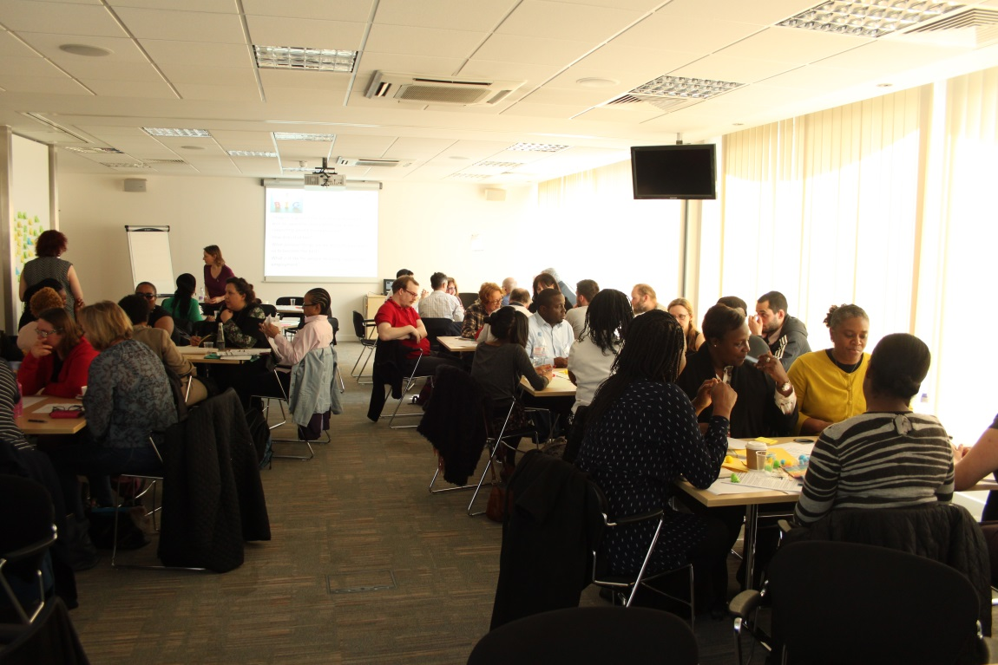

**(Journeys to sustainable employment in Hackney workshop March 2017)**

The City & Hackney Health & Social Care Forum has existed for over 30 years in one form or another. The HSCF was originally set up to ensure the effective involvement of health and social care voluntary and community sector (VCS) organisations and groups in the local Joint Consultative Committee and Joint Planning structures.

HSCF is a network of 140 Voluntary & Community Sector (not for profit) groups working in Health & Social Care in Hackney & the City. The member groups vary in size and function. The forum is a network of voluntary & community sector groups with an interest in health & social care. It is open to any interested individuals or groups. Join us via this website.

Our aims are to ensure:

* the Voluntary & Community Sector (VCS) perspective is heard in the Health & social Care planning & commissioning of services in City & Hackney
* that we have accountable and supported VCS representatives in Health & Social Care planning & commissioning meetings in City & Hackney
* that Health & Social Care VCS groups have opportunities to network and to share good practice in City & Hackney
* that Health & Social Care VCS groups have access to quality information on local & national policy, planning, funding that will assist them to deliver quality services to Hackney residents.

We offer:

* Networking opportunities through seven regular network groups ;
* Forum meetings, seminars and conferences on areas affecting local groups;
* Representation of VCS perspective via accountable VCS reps;
* A weekly newsletter with funding, jobs, local and national policy, events;

We aim to bring groups together to:

* share good practice;
* share resources;
* develop partnerships and consortia;
* support VCS groups & representatives to input into statutory policy & planning meetings.

**Our Achievements**

The Forum has contributed significantly towards the policy direction in Hackney over the past few years including:

* **Supporting the Voluntary & community Sectors Diversity**

Developing City & Hackney Together, an organisational structure managed by Hackney CVS that enables consortia bidding, by achieving ‘buy in’ from both the local sector and statutory sector partners. (this was developed following joint meetings with LBH and the HSCF to look at different models.)

* **Supporting role of VCS in Integrated Care**

contributing to the overall One Hackney and City model, and designing the VCS role in this including how it would practically work.

* **Working to ensure there is coordinated Information about local services and activities:**

In 2015/16 the Forum championed and actively pursued the integration of resident facing information, took over the maintenance of iCare and made recommendations for the joining up of the back end of iCare. In 2016/17 we have continued to work to influence this agenda, and have brokered relationships between the iCare Steering Group and the North East London Directory of Services, the GP confederation and GLL and are now working to ensure CCG led patient referral pathways link to iCare.

* **Patient Activation and Self Care – user led training**

In 2014/15 we developed the concept and got a proposal funded for a service user led training project – the aim of this programme is to set up a stand alone user led social enterprise. In 2016/17 this programme was continued by HENCEL and the programme gained additional external funding to extend this model to other mainstream services, leisure and libraries

* **Patient Activation and Self Care – Peer Support and showing the value of community organisations**

In 2014/15 we developed and piloted a community led ‘peer support’ approach to long term conditions , including a grants programme, with attached training and support for community organisations who work with people who identify by ethnicity / language, or by health condition – mental ill health or learning disabilities , or geographically to reach those who need support to self care / manage their long term conditions. In 2016/17 This programme was continued and extended to all long term conditions .

**Achievements 2016/17**

* Developing a strategy to ensure that the local Voluntary & Community can play a full part in the transformation of health and social care locally, with consultant support (in progress).
* Developing links and clarity of offer with Business support agencies to improve the uptake and benefits of pro bono support locally.
* Reinstating regular meetings with the DWP and local organisations to improve joint working and support for local residents.
* Setting up a Supported Employment Network and holding a workshop bought together providers, referrers, service users and commissioners. (The results of this workshop are being developed into a strategy in 2017/18)

**Structure of the Health & Social Care Forum Networks Meetings:**

**Health & Social Care Forum Steering Group –** The steering group is made up of all representatives and chairs of special interest groups. This is the decision-making body and policy forum for the HSCF.

**Special Interest Groups (SIG’s) -** We currently have four Special Interest Groups that are for organisations and individuals that work in the following areas:

* Mental Health. The Mental Health Special Interest Group (The Group) exists to provide a forum in the London Borough of Hackney, and City of London, for anyone who has an interest in the provision of mental health services. The group is a sub-group of the City and Hackney Health and Social Care Forum.
* Learning Disabilities. The Learning Disabilities Special Interest Group (LDSIG) exists to provide a forum in the London Borough of Hackney, and City of London, for anyone who has an interest in the provision of services for people with Learning Disabilities. The group is a sub-group of the City and Hackney Health and Social Care Forum.
* Older People’s Special Interest Group brings together organisations working with older people and older residents. The SIG has worked on transport issues and will be looking at Dementia in 2017. The group is a subgroup of the City and Hackney Health and Social Care Forum.
* User led SIG: The role of this group is to bring user voice and user led groups and organisations together to:
  + Ensure the voice of service users influences the design and delivery of local services
* Coordinate activity and ensure we are not duplicating
* Provide peer support and share good practice
* Explore opportunities to develop user led services
* Understand what is happening within services and identify arising issues
* Act as a pre-meeting for the user and carer involvement reference group

**And three additional multi agency networking meetings that we support:**

* The Supported Employment Network – a new network that is:
  + mapping the pre-employment support for disabled people in the borough,
  + sharing good practice and
  + strengthening referral pathways
  + developing a strategy for how we collectively improve local employment rates for local disabled people.

This network includes commissioners and providers, referrers, employers and service users.

* The Sexual Health Network – this brings together practitioners in sexual health, including Community African Network, Young Hackney, Brook together to share good practice and plan awareness raising campaigns.
* DWP / Voluntary & Community Sector* quarterly updates, this is an open forum for all who are giving advice and supporting people on benefits to receive the latest information on Government legislation and changes to the benefit system and discuss how we can locally attempt to support people through the changes.

* HSCF will be taking on the support for Hackney Advice Forum who previously supported this quarterly forum in 2017.

These network meetings enable local organisations to:

* meet
* share good practice
* agree common issues
* influence statutory decision making

**Forum Meetings** Bring together all the membership to discuss cross cutting themes, ensure dissemination of information, and the opportunity to develop joint working.

Full forum meetings happen quarterly and will be themed on Transformation of Health & Social Care for 2017/18